NON-TECHNICAL SUMMARY
ON
ECOLOGICAL ASSESSMENT REPORT OF
the projects of the Cross-Border Cooperation Program 2021-2027, co-financed under the Instrument for Pre-Accession Assistance, between the Republic of Bulgaria and the Republic of North Macedonia and the Territorial Strategy for Integrated Measures

Client: Ministry of Regional Development and Public Works
Contractor: „BT Engineering“Ltd

December, 2021
TABLE OF CONTENTS
INTRODUCTION 5
1. Name, registered office and unique identification number of the legal entity 6
2. Full postal address 6
3. Phone, Fax, E-mail 6
1 Description of the content of the main objectives of the CBCP and TSIM and connection to other relevant plans and programmes 7
1.1. Reason for drawing up the CBCP and the TSIM 7
1.2. Main targets and provisions of CBCP and TSIM 7
1.3. Alternatives to CBCP and TSIM 14
1.4. Relation of CBCP and TSIM with other relevant plans, programs and strategies 14
1. Current state of the environment and possible development without the application of CBCP and TSIM 15
1.1. Current state of the environment 15
1.1.1. Climate and climate change 15
А. Climatic characteristics 15
Б. Climate change 16
1.1.2. Atmospheric air quality 17
1.1.3. Water condition, water protection zones, flood risk 17
1.1.4. Condition of the earth's subsurface 18
1.1.5. Soil condition 18
1.1.6. State of biological diversity 18
1.1.7. Protected areas and protected territories 20
1.1.8. Landscape condition 25
1.1.9. Status of tangible assets 26
1.1.10. Cultural and historical heritage, including architectural and archaeological heritage 26
1.1.11. Condition with regard to harmful physical factors 26
1.1.12. Condition and management of waste 26
1.1.13. Hazardous chemicals and risk of major accidents 27
1.1.14. Health status of the population 27
1.2. Possible development of the environment without the application of CBCP and TSIM 28
2. Characteristics of the environment for territories that are likely to be significantly affected by the implementation of the CBCP and TSIM 30
3. Existing environmental problems identified at different levels related to the CBCP and TSIM, including those of areas of special ecological importance, such as protected areas under the Biodiversity Act 38
4. Environmental protection objectives at national and international level relevant to the CBCP and TSIM and the way in which these objectives and all environmental considerations have been taken into account in the preparation of the program and strategy 39
4.1. Integration of environmental protection objectives in the projects of CBCP and TSIM 39
4.2. Environmental protection objectives at international and national level, relevant to CBCP and TSIM and the way in which they are complied with 39
5. Likely significant effects on the environment and human health, incl. and transboundary environmental impacts in other countries 39
5.1. Assess the likely impacts at the Strategic level 40
5.1.1. For CBCP 40
5.1.2. For TSIM 41
5.2. Assessment of the likely impacts at the level of "activities/measures" 41
5.2.1. For CBCP 41
5.2.2. For TSIM 45
5.3. Cumulative impact 47
5.4. Transboundary impact of CBCP and TSIM 49
5.5. Summary of the impact 49
6. Foreseen measures to prevent, reduce and compensate as fully as possible the adverse effects of the implementation of the CBCP and TSIM on the environment and human health 51
6.1. Measures to reflect in the final versions of the CBCP and / or TSIM 51
6.2. Implementing measures for the implementation of CBCP and / or TSIM 52
7. Reasons for choosing the considered alternatives 55
8. Methods for carrying out the ecological assessment, used normative base and documents and difficulties in gathering the necessary information 55
9. Measures in connection with the monitoring during the implementation of CBCP and TSIM 56
10. Conclusion of the environmental assessment 57
11. Given the above, the implementation of CBCP and TSIM is preferred in terms of environmental and human health impact over the "zero" alternative 59

LIST OF ABBREVIATIONS
BCP | Border crossing point
ICE | Internal combustion engine
EAR | Environmental Assessment Report
LTTA | Long-term tangible asset
EA | Environmental assessment (Strategic environmental assessment within the meaning of Directive 2001/42)
EU | European Union
BDA | Biodiversity Act
ACI | Areas of community importance
ICT | Information and communication technologies
SMEs | Small and medium enterprises
NGO | Non-governmental organizations
OIP | Ornithologically important place
EIA | Environmental impact assessment
AC | Assessment of compatibility (with the subject and objectives of protection of protected areas of the ecological network "Natura 2000")
CBCP | Cross - border Cooperation Program
RBMP | River basin management plan
FRMP | Flood risk management plan
SPA | Special protected areas
SCA | Special conservation areas
TSIM | Territorial strategy for integrated measures
IUCN | International Union for Conservation of Nature
NUTS | The nomenclature of territorial units for statistics
SUDS | Sustainable urban drainage systems
TEN-T | Trans - European network- transport

INTRODUCTION
This document has been prepared within the framework of contract № RD-02-29-88 / 16.04.2021 with subject: “Elaboration of environmental assessment report for INTERREG - IPA CB cooperation programme 2021 – 2027 between the Republic of Bulgaria and the Republic of North Macedonia and for Cross-border Strategy for Integrated Territorial Development to be financed under the INTERREG - IPA CB cooperation programme 2021 – 2027 between the Republic of Bulgaria and the Republic of North Macedonia ",with identification number Interreg -IPA CBC-TA-2020-4/Lot 3, signed between: Ministry of Regional Development and Public Works of the Republic of Bulgaria (Contracting Authority) and BT-Engineering Ltd (Contractor).

This non-technical summary presents shortened and aggregated information on the content, main results and conclusions of the environmental assessment report (strategic environmental assessment) of the draft Cross-border Cooperation Programme (CBCP) 2021-2027, co-financed under the Instrument for Pre-Accession Assistance, between the Republic of Bulgaria and the Republic of Turkey and the draft Territorial Strategy for Integrated Measures (TSIM).
The environmental assessment report has been prepared in accordance with the national legislation of the two countries transposing the requirements of Directive 2001/42/EC of the European Parliament and of the Council of 27 June 2001 on the assessment of the effects of certain plans and programmes on the environment (Directive 2001/42/EC).
The main objectives of the report are to integrate environmental considerations into the projects of the CBCP and TSIM in the process of their preparation by:
- an analysis of the current condition and problems of the environment, including in relation to human health in the cross-border area subject to CBCP and TSIM,
- an assessment of possible impacts, including significant ones, on the environment and human health resulting from the provisions of the CBCP and TSIM projects, motivating the choice of the most environmentally and human health-friendly alternative for their implementation;
- Proposing measures to prevent, reduce and compensate as fully as possible of adverse effects and measures to monitor and control environmental and human health impacts in the implementation of the CBCP and TSIM.
The non-technical summary has been prepared as part of the required documentation according to point (j) of Annex No I to Article 5(1) of Directive 2001/42/EC, it has been prepared in a language that is broken down for the general public, does not contain technical terms and includes the relevant visual materials.
The non-technical summary, as an independent but inseparable annex to the Environmental Assessment Report, shall be provided together with the report and all other annexes, including the drafts of the CBCP and TSIM for consultation pursuant to Art. 6 of Directive 2001/42/EC.

CONTACT INFORMATION WITH THE ASSIGNOR
- Name, registered office and unique identification number of the legal entity
Ministry of Regional Development and Public Works
- Full postal address
Sofia 1202, st. 17-19 "St. St. Cyril and Methodius”
- Phone, Fax, E-mail
Contact person: Desislava Georgieva - Director of the Territorial Cooperation Management Directorate
Phone: 02/9405 488
E-mail: D.G.Georgieva@mrrb.government.bg

- Description of the content of the main objectives of the CBCP and TSIM and connection to other relevant plans and programmes

This section of the environmental assessment report examines the rationales for the preparation of the CBCP and TSIM, their predictions, the availability of alternatives for the predictions and their relationship to other strategies, plans and programmes.

1.1. Reason for drawing up the CBCP and the TSIM
The preparation of the CBCP and TSIM is in line with the European legislation, and in particular – Regulation (EU) 2021/1060 of the European Parliament and of the Council of 24 June 2021 laying down common provisions on the European Regional Development Fund, the European Social Fund Plus, the Cohesion Fund, the Just Transition Fund and the European Maritime, Fisheries and Aquaculture Fund and financial rules for those and for the Asylum, Migration and Integration Fund, the Internal Security Fund and the Instrument for Financial Support for Border Management and Visa Policy (Common Provision Regulation) and Regulation (EU) 2021/1059 of the European Parliament and of the Council of 24 June 2021 on specific provisions for the European territorial cooperation goal (Interreg) supported by the European Regional Development Fund and external financing instruments (Interreg Regulation).
Compliant and applicable national legislation for cross-border programmes.
The CBCP and TSIM shall be financed by the European Union with funds under the Instrument for Pre-Accession Assistance.
The Ministry of Regional Development and Public Works of Republic of Bulgaria is Managing Authority under the program.

1.2. Main targets and provisions of CBCP and TSIM
А. The CBCP 2021-2027 between the Republic of Bulgaria and the Republic of North Macedonia has a geographical scope:
- Republic of Bulgaria: 2 NUTS III districts: Blagoevgrad and Kyustendil;
- Republic of North Macedonia: 3 NUTS III regions: Northeast, East and Southeast.
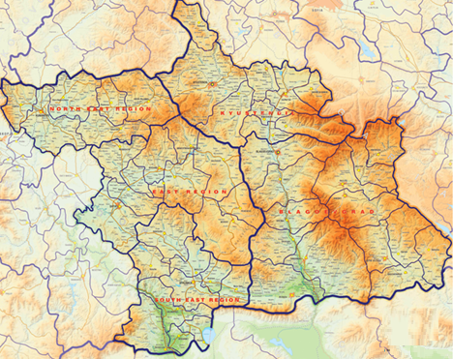
Figure № 1.2-1 Territorial scope of the CBCP 2021-2027 between the Republic of Bulgaria and the Republic of North Macedonia
The main common challenge of the region for cross-border cooperation for the period 2021-2027 is to leave the group of lagging regions and take a more advanced course of development, while still facing persistent problems related to the risk of poverty and inequality in in terms of income due to negative demographic change, underdeveloped regional value chains and entrepreneurship, low technological specialization, unattractive and uncompetitive economic environment.
The territorial analysis carried out for the purposes of programming and its updated version provide an opportunity to structure the main findings in the following groups of policy areas, considered in terms of obstacles and drivers of development:
- Negative demographic change;
- Poverty and income inequality;
- Differences in educational results and results in the field of employment;
- Inequality in access to health care;
- Discrepancies in the competitiveness and business environment;
- Insufficient acceptance of digital innovations;
- Underdeveloped year-round tourist infrastructure;
- Lack of ecosystem-based practices and services for dealing with natural disasters and loss of biodiversity;
- Limited readiness for ecological transition;
- Limited cross-border connectivity and intra-regional mobility.
- Based on the territorial analysis, they have been identified as driving forces for development
:
- Favorable macroeconomic context and results for small and medium - sized enterprises (SMEs);
- Rich biodiversity with a strong impact on economic growth.

The Programme identifies the following Policy Objectives (of the Common Provision Regulation) and related Priorities, Specific Objectives and Supported Activities/Investments

Policy objective 2
A greener, low-carbon transitioning towards a net zero carbon economy and resilientEurope by promoting clean and fair energy transition, green and blue investment, the circular economy, climate change mitigation and adaptation, risk prevention and management, and sustainable urban mobility
Policy objective 5
A Europe closer to citizens by fostering the sustainable and
integrated development of all types of territories and local initiatives
Policy objective 3
A more connected Europe by enhancing mobility

Priority 3
Integrated development of the cross-border region (integrated territorial development of the regions)
Priority 2
More connected border
region (communication links, extended access to the core TEN-T)
Priority 1
Greener
Border region (green infrastructure)

Specific objective 1.1
Enhancing protection and preservation of nature, biodiversity, and green infrastructure, including in urban areas, and reducing all forms of pollution
Specific objective 3.1
Fostering the integrated social,
economic and environmental development, cultural heritage and security in areas other than urban

Specific objective 2.1
Developing sustainable, climate resilient, intelligent and intermodal national, regional and local mobility, including improved access to TEN-T and cross-border mobility

Figure № 1.2-2 Thematic concentration of CBCP 2021-2027 between the Republic of Bulgaria and the Republic of North Macedonia
The content of the priorities is as follows:
Priority 1: Greener Border region (green infrastructure)
Policy objective 2: A greener, low-carbon transitioning towards a net zero carbon economy and resilientEurope by promoting clean and fair energy transition, green and blue investment, the circular economy, climate change mitigation and adaptation, risk prevention and management, and sustainable urban mobility
Specific objective 1.1: Enhancing protection and preservation of nature, biodiversity, and green infrastructure, including in urban areas, and reducing all forms of pollution
List of actions/investments to be supported:
- Investments in building greens (green balconies, green walls, green roofs, atrium spaces, green pavements, green parkings, green fences, noise barriers, etc.);
- Investments in developing urban and peri-urban green areas, including improving connections between green spaces (tree alley and street tree/hedge, street green and green verge, green playground/school ground, green and colored squares, riverbank greens);
- Investments in developing natural urban green areas (urban park, historicalpark/garden, pocketpark/park let, neighbourhood green space, institutional green space, green sport facility, forest, shrubland, abandoned and derelict area with patches of wilderness);
- Investments in developing green areas for water management (swales, creek restoration and nature scaping, rain gardens or sustainable urban drainage systems (SUDS), naturalized storm water pond, bio retention areas);
- Support for joint strategies and action plans for developing new tools, instruments, as well as transferring solutions between relevant stakeholders;
Target groups:
Local population and visitors, Local authorities and regional structures of central administration, R&D, academic and scientific institutions, NGOs

Priority 2. More connected border region (communication links, extended access to the core TEN-T)
Policy objective 3: A more connected Europe by enhancing mobility
Specific objective: Developing sustainable, climate resilient, intelligent and intermodal national, regional and local mobility, including improved access to TEN-T and cross-border mobility
Strategic project: “Establishment of a new Border cross check point (BCCP) „Klepalo” between the Republic of Bulgaria and the Republic of North Macedonia”
Main project goal of the project is to improve regional connectivity and to boost the economic growth of the CBC area. Specific project objectives:
- To facilitate the increasing traffic of people and goods between the two countries
- To strengthen communication lines between the two countries
- To improve and extend access to the core TEN-T network.

Indicative project activities:
- Upgrade of the existing and construction of new BCCP facilities;
- Purchase of specialized technical equipment based ICT solutions;
- Rehabilitation of existing and construction of new roads in both countries;
- Environmental and other project-related assessments

At present, in the previous programming period 2014-2020 and before it, the following activities have been implemented under the project:
- On the territory of the Republic of Bulgaria:
The construction of CBP infrastructure and sites, as well as the leading road is forthcoming. Complex investment design has been assigned - cadastral map, plot plan for land expropriation, The detailed development plan-regulation and construction plan for the engineering and building infrastructure of CBP, investment project - technical phase.
Part of the project for the Bulgarian territory is the repair and completion of road III-1008 Strumyani - Klepalo CBP. A contract has been concluded by RIA with a contractor for the development of a technical project for rehabilitation of section 1 from km 0 + 000 (near the village of Strumyani) to km 0 + 650 (before the road junction of the Struma highway). The aim is to restore and improve the technical and operational qualities with the overhaul of the section, to increase the bearing capacity of the road surface and to improve the drainage. For section 2 is included the elaboration of a preliminary design for the construction of a new route on road III-1008 from km 22 + 000 (before the road diversion for the village of Kolibite) to the beginning of the site of the Klepalo CBP. On the basis of the developed conceptual design, a technical design will be prepared along the route approved by the competent authorities with a detailed zoning plan - plot plan for terrain provision for the completion of the road. At the moment, the first stage has been developed - route variants. EIA and AC procedures are to be carried out.
- On the territory of the Republic of North Macedonia:
The new Klepalo BCP has been built to a significant extent, incl. the complex of engineering infrastructure and buildings, as well as the access road have been built.
Upgrading of the project documentation and bringing the construction in compliance with the requirements of the current regulations for BCP.
Priority 3 Integrated development of the cross-border region (integrated territorial development of the regions)
Policy objective 5: A Europe closer to citizens by fostering the sustainable and integrated development of all types of territories and local initiatives
Strategic objective 3.1: Achieving integrated territorial development focusing on competitiveness and tourism development.
Priority 3, for the implementation of Policy Objective 5 "Europe closer to the citizens", foresees the development of a Territorial Strategy for Integrated Measures (TSIM), which will address the measures (identified eligible support activities under the program) by specific territorial needs.
The integrated approach for meeting/addressing the needs and potentials of the territory in the developed TSIM is manifested in three main aspects:
- territory defined on the basis of achieving sustainable results in terms of common needs and potentials for development;
- participation of a wide range of partners in the whole process of preparation, discussion, adoption and implementation of the strategy.
- derived package of interconnected and complementary (integrated) measures, based on close coordination of different public policies according to local specifics, meeting local needs and development potentials and bringing common benefits to partners and the region.
Through TSIM it will give priority to support for some projects /actions /activities over others – are described below in the TSIM description as measures.
Target groups:
Civil society; Local/regional authorities, regional structures of central public authorities; NGOs; Research and development, academic and training institutions; Social Institutions, Micro, Small and Medium Enterprises (SMEs); Local population.

B. TSIM 2021-2027 between the Republic of Bulgaria and the Republic of North Macedonia
The TSIM defines the Vision of the CBCP, the strategic objective, specific objectives (described above in Priority 3 of the CBCP) and the measures.
Vision: The CBC regions of the Republic of Bulgaria and the Republic of North Macedonia: a place for consolidation and stability of the cultural and historical heritage through joint efforts for mutually beneficial cooperation, socioeconomic cohesion and balanced sustainable development.
The area within the TSIM geographic scope is characterized by common needs and development potentials and is essentially a functional area, but a more deeply tailor-made intervention approach allows for identification of Intensive intervention zones in it.
The local context specifics determine the determination of four such zones (Figure No. 1.2-3). Each of them also contains at least one development center of higher-level (large city) and is thus connected to the core of the polycentric network. This connection has not only a spatial but also a functional dimension - in larger and more developed cities it is easier to achieve results in the field of new technologies (green, circular, digital) and there it is most likely to take the first steps and to give a push the whole territory development.
The zones overlap/intersect over each other. The different cities and the surrounding territories fall into several different zones at the same time, which determines their profile in terms of the intensity of the different interventions/measures.
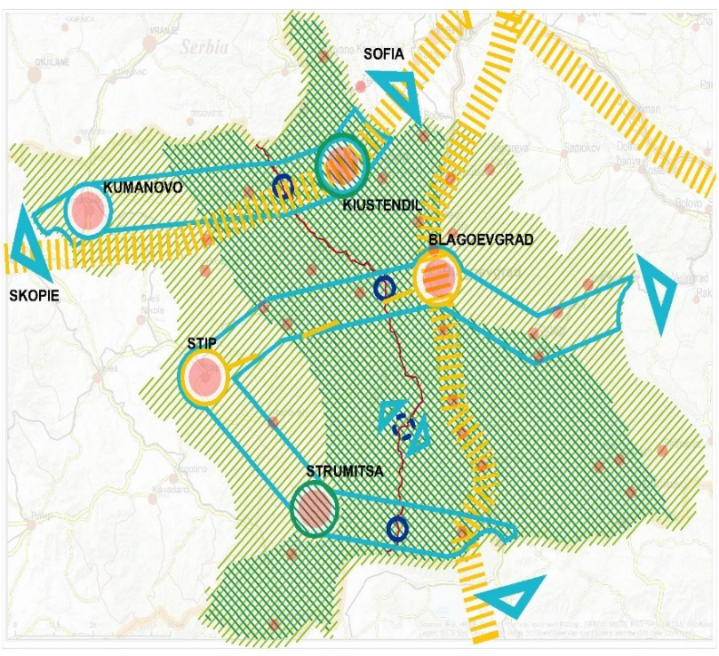
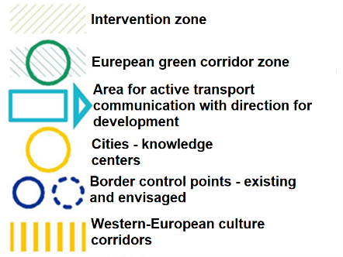

Figure № 1.2-3 Identified intensive intervention zones between the Republic of Bulgaria and the Republic of North Macedonia in TSIM 2021-2027

Strategic objective: Achieving integrated territorial development focusing on competitiveness and tourism development.
Specific objective 1.1: Increase the competitiveness of the local economy and improve the business environment:
Measure 1.1.1. Actions aimed at increasing the productive capacity of the SMEs to become greener, more digital and more competitive (technological modernization);
Measure 1.1.2. Actions aimed at improving the knowledge capacity of the SMEs to operate in a greener, more digital and more competitive environment (acquiring new knowledge and skills, incl. access to external finances);
Measure 1.1.3. Actions aimed at building effective product development process (it encompasses all steps needed to take a product from concept to market availability) and reaching new markets (marketing, entrepreneurship, internationalization);

Specific objective 1.2: Development of an attractive, all-season tourism product by means of smart solutions that ensure universal access and participation.

Measure 1.2.1. Improving the mobility and connectivity of the transport and engineering infrastructure by a system of alternative mobility, including a grid of bicycle lanes, ‘dirt’ forest and country roads, helipads, etc.;
Measure 1.2.2. Development and marketing of integrated regional tourism products suitable for various activities through the inclusion of the cultural and historical heritage and natural assets; joint efforts for diversification of the forms of tourism services and the realization of all-season tourism in the CBC region;
Measure 1.2.3. Development of integrated targeted financial packages for supporting business activity and the creation of new SMEs in tourism with a focus on family businesses and the offering of local tourism products: wine and gourmet tourism, rural eco-tourism, cycling tourism, hunting and fishing, off-road tourism, etc.;
Measure 1.2.4. Creating a joint network of locations for the realization of concepts like ‘green school’, ‘in the country’, ‘visiting with...’, ‘made by...’, etc.;
Measure 1.2.5. Elaborating and applying joint measures for reducing the vulnerability of services in the tourism sector to the effects of pandemic and epidemic situations; promoting the development of health and recreational tourism: products and services related to physical exercise, outdoor sports, strengthening the immune system and improving the health status through spa procedures, climate therapy, mud therapy; combining short breaks of different kinds with individual travel;

1.3. Alternatives to CBCP and TSIM
The draft program and strategy do not contain alternatives.

1.4. Relation of CBCP and TSIM with other relevant plans, programs and strategies

The projects of CBCP and TSIM 2021 - 2027 are related to plans, programs and strategies:
- at European and international level;
- at national, regional and local level (falling within the territorial scope of the program and strategy in the Republic of Bulgaria and the Republic of North Macedonia).
In item 1.4. of the Environmental Assessment Report, the relevant plans, programs and strategies are reviewed and analyzed, and those that set goals for environmental protection are noted (for them an extended analysis has been made.).
- Current state of the environment and possible development without the application of CBCP and TSIM

  - Current state of the environment
Item 2.1 of the Environmental Assessment Report provides information on the state of the environmental components and factors at the moment (in order to establish the current state, observed positive and/or negative trends, which are important to take into account both in the assessment of the impact of the CBCP and TSIM, and in their subsequent implementation).
The state of the environment is examined by factors and components, the main results of the analysis being as follows:
    - Climate and climate change

А. Climatic characteristics
- Districts of Kyustendil and Blagoevgrad (Republic of Bulgaria)
District of Kyustendil
The area falls within the transitional continental climate area of the European continental climate area and in particular the Kyustendil-Blagoevgrad climate region. The climatic wind rose is characterized by protection from eastern and western invasions, characteristic of zonal air transport. There are a total of about 30 days in winter with temperatures below 0 ° C. The average January temperatures in the region are around the range +1 ÷ - 1°С.
District of Blagoevgrad
The climate in the district is determined by the transition between the transitional-continental and continental-Mediterranean climatic regions, with a strong influence of the Mediterranean climate in the southern regions of the district. It is characterized by warm, to hot summers and relatively mild winters, with a smaller annual temperature amplitude (about 22°C) and two maximum rainfall - late autumn and spring.
- Northeastern, Eastern and South-Eastern regions (Republic of North Macedonia
South-Eastern region
It is characterized by two climatic zones: transitional-Mediterranean to a greater or lesser extent continental climate, which provides the region with a specific feature - long hot summers with high lunch temperatures and reduced annual rainfall, reduced winter temperatures and winds from all directions. This area is the sunniest region in the Republic of North Macedonia. Due to the Mediterranean influences from the Aegean, the climatic conditions in the region are characterized by reduced annual rainfall and lower winter temperatures.
Eastern region
The climate in the Eastern region is dry. Characteristic of this type of climate are the long and dry summers, often with temperatures up to + 41°С with mild, humid winters, with rare cases of extremely low temperatures, which can reach -22°С. This is a result of the contact between the influences of the Mediterranean and the continental climate.
Northeast region
The climate in the Northeast region is mostly temperate to mountainous. Temperature differences vary with altitude and usually lead to moderately cold winters, moderately hot summers, cool springs and relatively warm autumns, which in some parts of the region are due to geographical location and some influences from the Aegean Sea through Kriva Reka river.

Б. Climate change
Climate change is a fact due to large-scale global processes in both the North and Southern Hemispheres. They mainly affect the regime of air temperature and precipitation, as well as the change of seasons. The general trend is to increase the global air temperature, increase evaporation and reduce rainfall, especially winter and increase extreme events such as floods, high temperatures and related fires and others..
Climate change is a threat to the regions, especially to those parts where agriculture, tourism, forestry and hydropower are well developed, as in the border region between the Republic of Bulgaria and the Republic of North Macedonia.
The two countries are expected to be hit hardest by climate change, mainly through rising temperatures and heavy rainfall and an increase in the frequency of extreme events such as droughts and floods.
The Republic of North Macedonia is generally less favorable characteristics to vulnerability and climate change due to lack of access to the sea. The border area is part of a region for which the 6th degree of vulnerability to climate change has been identified, according to the EU-wide index.
The most common hydrometeorological and natural disasters in the cross-border region (The National Strategy for Adaptation to Climate Change and the Action Plan until 2030 of the Republic of Bulgaria and draft National Long-Term Action Strategy for Climate Change of the Republic of North Macedonia 2020-2050) are extreme rainfall and temperatures, storms, floods, forest fires, landslides and droughts. The number of deaths and casualties due to natural disasters is significant, indicating vulnerability to weather and climate conditions. The vulnerability of the population and economy of both countries to the effects of climate change is exacerbated by the relatively high level of poverty, the uneven distribution of the population and the various consequences of the transition from a state-controlled economy to a free market economy. There is growing evidence that economic losses from weather and climate disasters are also on the rise.
Scientific forecasts suggest that average temperatures will rise between 1.8°C and 4°C by 2100, with the rise in Europe expected to be even higher than the projected global average.
The research conducted by the Department of Meteorology of the National Institute of Meteorology and Hydrology at the Bulgarian Academy of Sciences envisages an increase in the annual air temperature in Bulgaria from 0.7°C to 1.8°C by 2020. Even higher temperatures are expected by 2050 and 2080, with projected increases of 1.6°C to 3.1°C and 2.9°C to 4.1°C, respectively. In general, the increase in temperature is expected to be greater during the summer season (from July to September).
The expected temperature increases for the Republic of North Macedonia are between 1.0°C by 2025, 1.9°C by 2050, 2.9°C by 2075 and 3.8°C by 2100, while the average decrease in precipitation is in the range from -3% by 2025, -5% by 2050, -8% by 2075 to -13% by 2010 compared to the reference period. The largest increase in temperature in the Republic of North Macedonia is expected during the summer seasons, due to a sharp decrease in precipitation. There will be almost no change in precipitation in the winter, but changes are expected in other seasons.
Climate change requires adequate adaptation and sustainability actions to be integrated into future projects.
    - Atmospheric air quality
The analysis of data and assessments of climatic and meteorological conditions in these areas lead to the following conclusions about the processes and phenomena of interest for the current state of the environment:
- the average daily concentrations of fine dust particles (FDP₁₀) permanently exceed the average daily norm.
- there are no permanent exceedances of the norms for protection of human health for the other gas pollutants.
The main sources of dust pollution are:
- the use of solid fuels (coal and wood) in domestic heating during the winter months in settlements,
- construction activities - unorganized dust emissions from open construction sites,
- agricultural activities - unorganized emissions of dust from wind-blown soil when working in open fields,
- road transport - the re-subsidization of dust from uncleaned streets and unpaved roads.
- forest and agricultural fires - burning stubble.

    - Water condition, water protection zones, flood risk
Regarding the Republic of Bulgaria - due to the geographical location, atmospheric circulation and landscape the water balance is unsatisfactory in terms of space and time. In terms of water resources per capita, the country ranks second on the Balkan Peninsula. Bulgaria also faces serious challenges due to the location and arid zone, uneven distribution of water resources, depreciation of water supply systems and poor construction of the sewerage system. Construction of wastewater treatment plants is slowing down compared to water supply systems and many aquatic ecosystems are still at risk.
For the Republic of North Macedonia, the data confirm that climate change is already having a negative effect on three aspects of water quality:
-reduction of water resources, leading to degradation of qualities;
- high temperatures, leading to a decrease in dissolved oxygen;
-due to climate change, water use, especially in agriculture, increases pollutants released into the water.
The assessment shows a significant future reduction in water resources in the country. Frequent dry periods and stormy waters with increasing intensity are expected.
The total amount of water, especially in the catchment area of the Vardar River, is expected to decrease by about 18% by 2100. Extreme events such as drought, high temperatures and floods are expected to increase the need for drinking water. The need for drinking water for the city of Skopje is expected to be up to 2100 about 30%. Climate change is expected to increase the need for irrigation water.

    - Condition of the earth's subsurface
The geological and tectonic development of the territory in the cross-border regions of the Republic of North Macedonia and the Republic of Bulgaria have a similar character. The modern relief is mostly mountainous, with well-formed river valleys, valleys and lowlands. Erosion processes are characteristic of the raised parts of the relief, and the deposition of alluvial material takes place mainly in the valleys, lowlands and water basins.
As part of the Balkan Peninsula, the cross-border territories of the Republic of North Macedonia and the Republic of Bulgaria are highly endangered by the seismic activity of the earth's interior.

    - Soil condition
The soils of Blagoevgrad and Kyustendil districts are in good ecological condition, both in terms of nutrient reserves and in terms of pollution with heavy metals and metalloids. Increased urbanization is reflected in the destruction of agricultural land for non-agricultural purposes. Contamination or destruction of the soil cover has a local (spot) nature.
The soils in the Northeastern, Eastern and Southeastern regions of the Republic of North Macedonia are very diverse. They are subject to various types of influences, such as: destruction of non-agricultural land as a result of increased urbanization, industry / energy, transport; erosion, soil pollution (landfills, agriculture, mining), tourism, floods, forest fires, etc. The consequences of them are: sealing of the soil and changes in soil functions; soil erosion; local and diffuse pollution; soil acidification; desolation.

    - State of biological diversity
- Blagoevgrad and Kyustendil districts (Republic of Bulgaria)
The characteristic geographical position of the country, combined with the complex paleogeographic and paleoclimatic past, the diverse relief and climate, the presence of freshwater basins and the Black Sea access, as well as the formed diverse landscapes and geosystems are the main factors determining the rich diversity. and natural habitats in Bulgaria.
Regarding the condition of the vegetation, species and their populations in the considered area, the main limiting factors are the human activity leading to direct /destruction /and indirect /change of environmental conditions and fragmentation /impact of species (soil sealing related to construction of sites and infrastructure, pollution, change in the water regime due to drainage or construction of reclamation facilities). As there are developed tourist sites in the region, the tourist flow is also not an insignificant factor that has a negative impact on the plant world. The consequences of climate change - drought, forest fires and other extreme weather events - are becoming increasingly important.
The diversity of animal species and their habitats, many of them included in the Red Book of the Republic of Bulgaria, shows the need for a specific approach in the management of the territory in question, in order to preserve habitats and valuable ecosystems they maintain. Habitats, especially in the highlands, are most vulnerable to changing climates, with many isolated, sensitive to anthropogenic pressures and impacts.
One of the main migration routes of migratory birds passes through the two districts in Bulgaria, as well as in the west, in the border territory of the Republic of North Macedonia: Via Aristotelis (Trans-Balkan Road) - through the Struma River Valley, Sofia Field and Iskar Gorge.
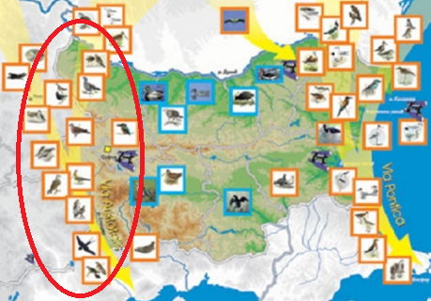
Figure 2.1.6-1 Migration route of migratory birds Via Aristotelis (in red)
It is the main route of migration of birds from Europe to Africa, passing through Western Bulgaria and the second largest number of migratory birds after Via Pontica.
The road connects the Danube with the White Sea, starting from the northwestern corner of the country in the Vidin region, passing through the Vratsa Balkans. From there, through the Iskar gorge, it crosses the Balkan Mountains and descends to the Sofia plain. From here along the valley of the river Struma it reaches the White Sea. The Mesta river valley is often cited as a branch of the Via Aristotelis.
- Northeastern, Eastern and South-Eastern regions (Republic of North Macedonia)
Although being small (25713 km²) and landlocked country, with its position in the centre of the Balkan Peninsula, the Republic of North Macedonia is one of the hotspots for biodiversity in Europe.
According to the analyses of biodiversity, Republic of North Macedonia is at the top of the list of states called “European Hotspots”. The great biodiversity of geographical areas of Republic of North Macedonia is a result of its long historical development. The differentiation of indigenous species, as well as the invasion of other area migrants, played a significant role in its genesis. Naturally, not all species once living in the area have survived. Many species disappeared due to unfavorable living conditions. Therefore, the recent biodiversity has to be studied, not only from a genetic but also from a historical point of view.
In the scope of the program in the Republic of North Macedonia, as identifying important plant areas on the side of Republic of North Macedonia, it is necessary to mention "Osogovo", "Skopje Montenegro", "Plačkovica", the area "Judovi livadi" (east of Pehchevo), where the common Sundews grows, Bogdantsi, Ovche Pole-Bogoslovets, Krivolak, Demir Kapiyska Klisura, Negorski Bani, Monospitovskoto Blato, Doyransko Ezero, Belasitsa. There are a large number of conservationally important plant species (included in the annexes to international conventions or lists).
The mountains cover a very large part of the territorial scope of the CBCP in the Republic of North Macedonia. Accordingly, animal species are characterized by varying degrees of conservation importance for the region, most of which are included under different regimes in the annexes of some international conventions for the conservation of biological diversity.
The considered cross-border area is extremely rich in plant and animal species, incl. with high conservation status at national and international level, incl. not a small number of endemics and relics (glacial and tertiary).
The main threats to its biological diversity are the change in the natural conditions of the environment as a result of future development of road and other connecting infrastructure, pollution, changes in water regime, logging, tourism, poaching, poison traps to kill large predators, redevelopment in some areas intended for resort purposes and others that are related to habitat change and affect habitat-specific animal species.
    - Protected areas and protected territories
- Blagoevgrad and Kyustendil districts (Republic of Bulgaria)
Protected areas of the European ecological network Natura 2000
Natura 2000 is a pan-European network of protected areas aimed at ensuring the long-term survival of Europe's most valuable and endangered species and habitats in accordance with the main international agreements in the field of environmental protection and biodiversity.
It must be established in all member states of the European Union and is a requirement for the accession of candidate countries of the union.
The sites in the ecological network are determined in accordance with two main environmental directives of the European Union - Directive 92/43/EEC on the conservation of natural habitats and of wild fauna and flora (hereinafter referred to as the Habitats Directive) and Directive 2009./147 /EA on the conservation of wild birds (hereinafter referred to as the Birds Directive).
In general, the Bulgarian part of the European ecological network Natura 2000 amounts to 34.4% of the territorial scope of the country, which ranks us one of the first places in Europe in this regard.
The process of issuing orders under the BDA for declaring protected areas for protection of wild birds has ended ("Special Protected Areas" - SPAs), and currently Bulgaria is in the process of concluding the issuance of orders for declaring protected areas for habitats, areas without warrants are designated as “Areas of Community Importance” (ACI), and areas with a completed warrants are designated as “Special Conservation Areas” (SCAs).
The territory of both districts includes all or part of a total of 40 protected areas of the ecological network "Natura 2000", data for which are presented in the two figures below:

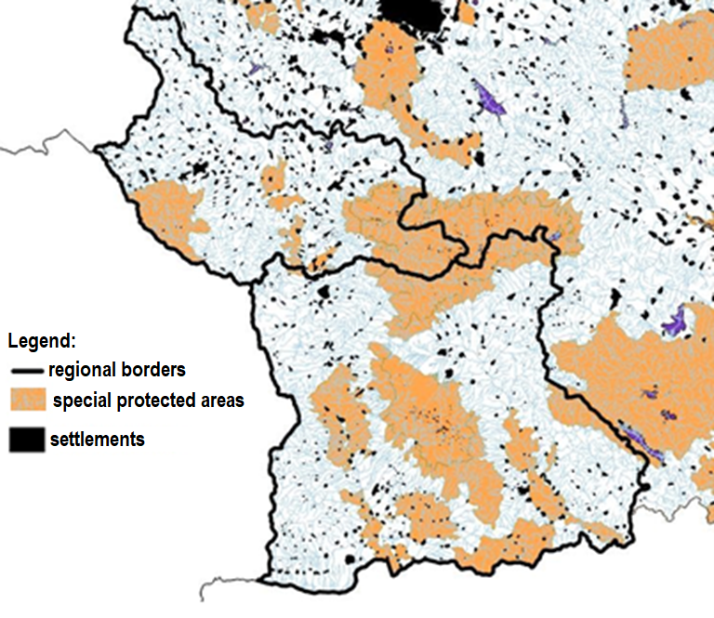

Figure 2.1.7-1 Map of SPAs in Kyustendil and Blagoevgrad districts

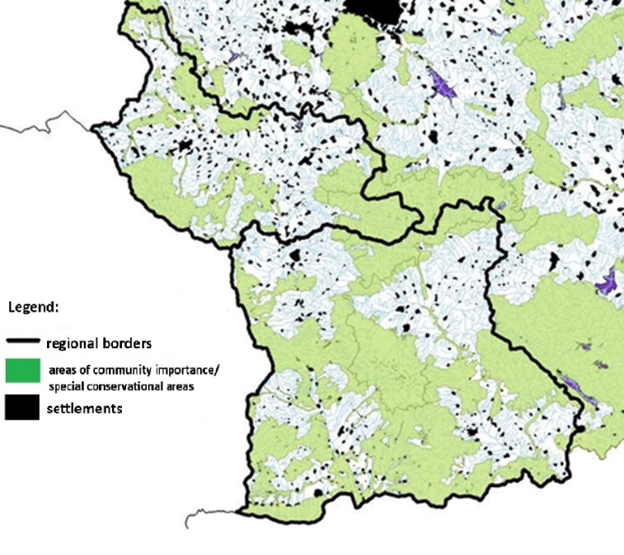

Figure 2.1.7-2 Map of SPA and SCA in Kyustendil and Blagoevgrad districts
Protected areas under the Protected Areas Act (PAA)
Since 1933, when the first protected area in Bulgaria was declared - the reserve "Silkosia" in Strandzha, and in 1934 the first national park on the Balkan Peninsula - "Vitosha", a consistent policy of expanding and strengthening the network of protected areas. .
Protected areas and their effective protection contribute to the implementation of a number of international conventions and agreements to which Bulgaria is a party:
The figure below shows the location of all categories of protected areas in both territories.

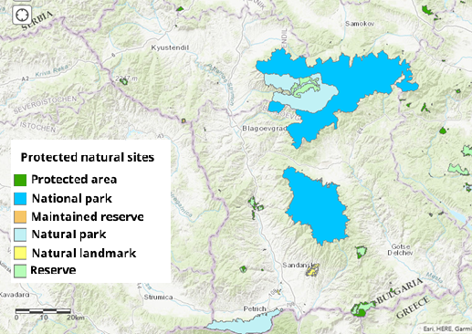
Figure 2.1.7-3 Map of the categories of protected areas in Blagoevgrad and Kyustendil districts

A total of 58 protected areas under the Protected Areas Act fall within the territory of Blagoevgrad District. The protected areas in the Kyustendil district are 23.
Ramsar sites
The territorial scope of CBCP and TSIM includes two potential Ramsar sites - Choklyovo blato (protected area), part of which is located in the village of Bunovo, Kyustendil municipality, and the Seven Rila Lakes (within the Rila National Park), also located in Kyustendil district, which should also be taken into account in order to prevent adverse effects, in the implementation of the program and strategy.
- Northeastern, Eastern and South-Eastern regions (Republic of North Macedonia)
Proposed protected areas of the European ecological network Natura 2000 (Emerald network and ornithologically important places - OIP)
As the Republic of North Macedonia is not a member of the Union, there are no lists of Natura 2000 protected areas officially established and adopted by the European Commission, but as a candidate it is preparing for the process of identifying and proposing such ones by preparing relevant proposals. . In this regard, the country has adopted the approach to use mostly the established territories of the Emerald Network (Emerald Network - Ecological network to conserve wild flora and fauna and their natural habitats of Europe), the established ornithologically important places on Birdlife like Bulgaria, as well as the established important places for plants, as they largely overlap.
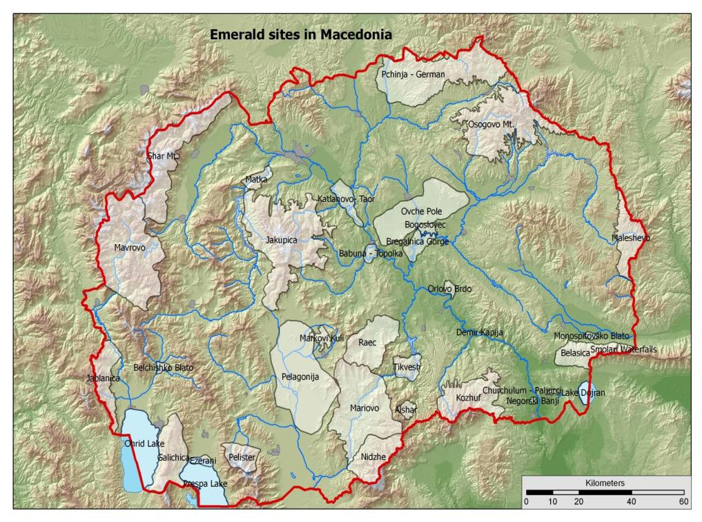
Figure 2.7.1-4 National Emerald Network (2011 GEF/UNDP/MoEPP Project “Strengthening the Ecological, Institutional and Financial Sustainability of Macedonia’s National Protected Areas System”)
12 Emerald areas are fully, two partially protected on national level within the boundaries of existing protected areas, while the rest is outside the network of protected areas.
It should be borne in mind that the final adoption of the lists of protected areas proposed by the candidate countries by the European Commission is part of the discussions during the so-called biogeographical seminars, which are part of the so-called Natura 2000 Biogeographical Process. Process). In view of this, at this stage, the areas considered above with the potential for inclusion in the future ecological network Natura 2000 of the Republic of North Macedonia should not be considered as final, but only as hypothetical..

Protected areas under the national legislation of the Republic of North Macedonia
The categorization of protected areas in the Republic of North Macedonia has been prescribed in the Law on Nature Protection, more or less harmonized with IUCN. The names of categories have been retained as those under IUCN categorization, maybe slightly modified or entirely changed. According to Ornat & Reines (2007), categories of protected areas in Republic of North Macedonia are classified as level 2 of harmonization with IUCN categorization, or categories are practically identical to those of IUCN, though IUCN is not referred to specifically in the national law. At present, the network of protected areas in Republic of North Macedonia comprises 86 areas proclaimed under under the appropriate IUCN category. A map of the currently existing national protected areas is given on the next figure.
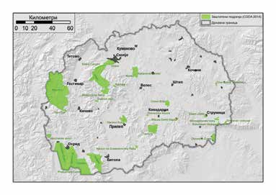
Figure 2.1.7-5 Map of the current National network of protected areas in the Republic of North Macedonia

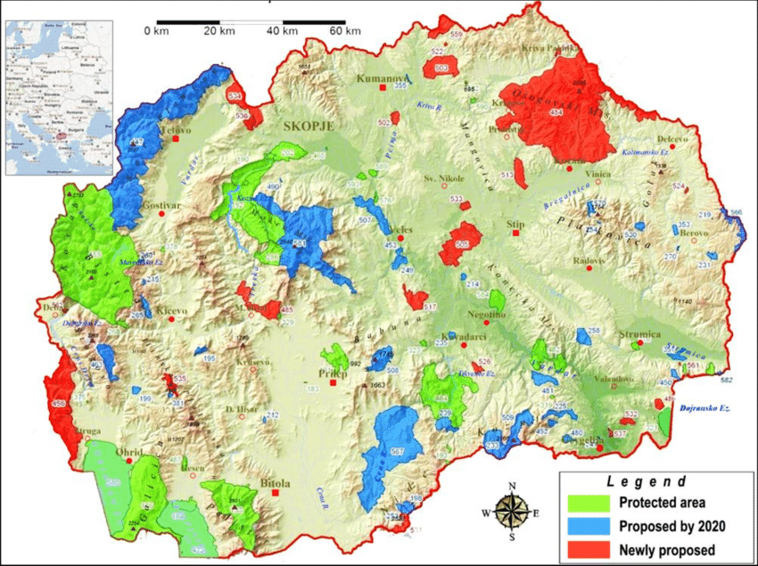
Figure 2.1.7-6 Map of the potentially future National network of protected areas in the Republic of North Macedonia
In accordance with the obligations of the Convention on Wetlands of International Importance especially as Waterfowl Habitat (Ramsar, 1971), the Ramsar List includes тwo protected areas of the Republic of North Macedonia: Prespa Lake (1995) and Dojran Lake (2007). The second is located within the territorial scope of the program and it is separated between Republic of North Macedonia and Greece.
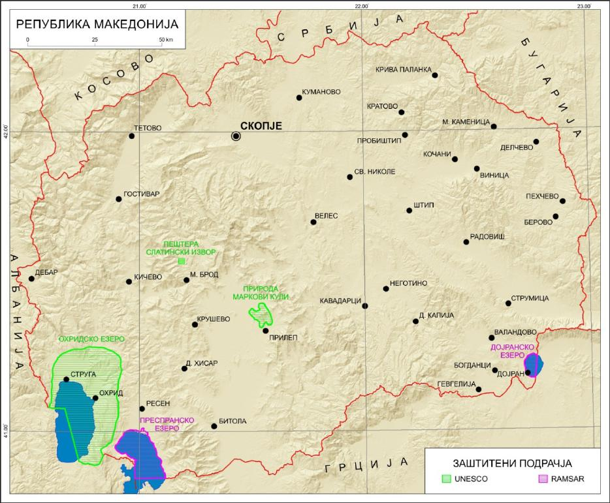
Figure 2.1.7-8 Ramsar sites in the Republic of North Macedonia

The territory of the cross-border area is extremely rich in valuable natural areas under legal protection. All activities should be in accordance with the management regimes according to the normative regulation, the normative and administrative acts for the declaration of the protected territories and zones, as well as with their management plans.

    - Landscape condition
In addition to national legislation, the European Landscape Convention plays an important role in the protection of the landscape. The main objective of the Convention is to preserve the European cultural and natural heritage, which defines the appearance of the pan-European landscape.
The location, the relief and the climatic features of the cross-border area contribute to the presence of its great landscape diversity. Mountain and valley landscapes prevail, as well as anthropogenic compared to natural landscapes. Specifically in the border area, the absorption of the territory and the degree of urbanization is significantly lower than in the direction of the interior of the two countries. The richness of the area of ​​natural, incl. sensitive landscapes, sets high requirements and many restrictions on the activities that can be carried out in this area.

    - Status of tangible assets
The condition of tangible assets shows the need for targeted measures to overcome the following main shortcomings:
- Insufficiently developed and maintained infrastructure for access to cultural and historical sites and natural landmarks;
- Insufficient joint actions in the field of cultural heritage exchange;
- Insufficiently developed infrastructure referring to environmentally friendly, alternative and green solutions for improving the urban and rural environment and meeting the needs of the region for a high standard of living
- Insufficient information and communication connectivity and digitalization
- Differences in administrative systems and approaches to the protection of natural and cultural heritage;
- Low level of information security and awareness;
On the other hand, the analysis shows the presence of exceptional potential for the development of cross-border infrastructure and the establishment of areas with different functions - culture, environment, tourism and recreation, sports, health, social services, labor and employment, ie. potential for developing cross-border multifunctional areas in support of a more connected and competitive region.

    - Cultural and historical heritage, including architectural and archaeological heritage
The cross-border area is rich in cultural values, for which adequate protection and maintenance should be ensured. They determine the high potential for the development of cultural tourism, which on the one hand will make a significant contribution to the provision of financial resources for conservation, and on the other - will contribute to the development of additional employment, additional income and improving the quality of life of local people.

    - Condition with regard to harmful physical factors
Of the harmful physical factors, noise is of the greatest importance for the region - increased values are found mainly in cities, in the territory of both countries. For the Bulgarian territory the increased noise levels are mainly due to transport. For the Republic of North Macedonia, exceedances have been established for terrains close to production, according to the available data.
No exceedances or problems were reported for the other harmful physical factors.

    - Condition and management of waste
For the territory within the scope of the Republic of Bulgaria: The main method of treatment of mixed municipal waste is landfilling, with positive trends in reducing the amount of landfilled waste with the introduction of pre-treatment facilities. The main problems are the lack of installations and facilities for the recovery of construction waste and the unregulated disposal of household and construction waste.
For the territory within the scope of the Republic of North Macedonia: waste management in planning areas can be characterized as inefficient and hampered by serious shortcomings, including: low public awareness, lack of consensus on the location of regional landfills for non-hazardous waste, lack of stricter requirements for generators. waste, leading to continuing adverse effects on the environment and human health.

    - Hazardous chemicals and risk of major accidents
In the cross-border area subject to CBCP and TSIM there are also existing enterprises with low and high risk potential of a major accident, and information on their location and parameters is not public.
When implementing activities and measures under CBCP and TSIM related to the construction of sites and infrastructure, it is necessary to take into account the existing enterprises in the area, performing activities for storage / production / use of hazardous chemicals and mixtures in quantities that pose a risk of large accidents.

    - Health status of the population
According to the presented data for the whole cross-border area of ​​CBCP and TSIM, depopulation continues with main characteristics - low birth rate, high overall mortality and migration processes, which lead to negative natural population growth. The maintenance of these negative values ​​of natural growth is a result of the aging of the population and changes in its reproductive attitudes, the latter being largely due to the low standard of living.
For the districts in the Republic of Bulgaria it is established that, unlike Blagoevgrad district, the indicators for Kyustendil district are more unfavorable than the national average.
The tendencies in the Eastern region are the most unfavorable for the regions in the Republic of North Macedonia.
In both countries, mortality by cause shows a leading place for circulatory diseases, followed by neoplasms, and for the Republic of North Macedonia in third place are diseases of the respiratory system, which may be associated with deteriorating air quality.
For the Republic of Bulgaria - in Blagoevgrad district, in the first place in the hospitalized morbidity are the diseases of the respiratory system, and in Kyustendil - in third place. For the Republic of North Macedonia there are no publicly available official statistics on morbidity and morbidity.
From the analysis of the risk factors for human health for the cross-border region in the first place are air pollution and increased noise levels in some cities in both countries. For the Republic of North Macedonia the additional risk is posed by the shortage and unsatisfactory quality of drinking water in some settlements, the current state of municipal waste management (tendency to form a significant number of unregulated landfills and use of municipal landfills that do not meet regulatory requirements). Risks related to climate change are becoming increasingly important for the entire cross-border region.
  - Possible development of the environment without the application of CBCP and TSIM

Based on the analysis of the data from the environmental characteristics in the previous item 2.1 of the EAR, the following table assesses the development of environmental aspects without the application of CBCP and TSIM by components and factors of the environment, incl. human health. In this way, the impact of the "zero alternative" was assessed, ie. refusal to implement CBCP and TSIM.
Table 2.2-1 possible development of the environment without the application of CBCP and TSIM
Components and environmental factors | Development without application of CBCP and TSIM
Climate and climate change | Existing and new sources of greenhouse gases will increase their emissions, but their levels will be negligible, both for both countries and globally. Over the last three decades, emissions of basic greenhouse gases (GHGs) have tended to decrease. This trend is expected to continue without the implementation of CBCP and TSIM.
Atmospheric air | Without the implementation of CBCP and TSIM the modernization of existing and construction of new buildings, energy efficient installations, rehabilitation of existing and construction of new roads, construction of green areas to reduce gas and dust pollutants will be delayed. The economic development of the cross-border region is slowing down, benefits for financing and additional investments will be missed, as well as absorption of funds from the European Union, respectively - improvement of working conditions, improvement of quality of life, healthy lifestyle, respectively provision of pleasant environment. preserving the rich nature on the basis of sustainable development of the environment.
Surface waters | Most of the goals, visions, priorities, specific and strategic goals have a positive impact on surface waters. In case of non-application of CBCP and TSIM, the development of surface waters will be unfavorable because:  - there will be no positive impact from territorial cohesion, a greener and more connected border region;  - there will be no mutual cooperation, which could lead to adverse effects on surface waters.  - the control over the planned tourist initiatives will be lowered.
Underground water | No development is expected
Earth's subsurface | No development is expected
Soils and land use | The non-implementation of CBCP and TSIM has a less favorable impact than their implementation, as the opportunities for financing activities and measures related to the control of processes leading to soil degradation in urban areas (sealing, pollution, erosion) will be missed. and extra-urban environment (destruction of soil organic matter due to: mechanical damage to the integrity of the soil profile; compaction; deterioration of the soil microbocenosis in disturbed water, air and heat regime of the soil, fires and floods).
Vegetation and fauna | No development is expected
Protected areas and territories | No development is expected
Landscape | The trends will remain the same as at the moment - the problems related to unregulated landfills, lack of sufficient green areas in the urban environment will deepen.
Tangible assets | In case of non-application of CBCP and TSIM, the development of tangible assets will be unfavorable because:  - there will be no positive impact from territorial cohesion and the achievement of a more interconnected border region;  - there will be no positive impact to achieve a greener cross-border region with improved mobility and developed alternative infrastructure  - the identified opportunities for the development of tourist and cultural events, and hence the stimulation of the local economy, balanced development and achieving competitiveness of the business environment will not be realized.
Cultural-historical heritage | No development is expected, and the benefits for protection, promotion, incl. increasing and diversifying the sources of income for the territories within the scope of CBCP and TSIM.
Harmful physical factors | The non-implementation of CBCP and TSIM will lead to the continuation of the tendencies for higher noise emissions emitted by road transport. The opportunity to finance and implement activities related to the achievement of the priorities and objectives set by the two documents will not be used.  No change in trends with regard to other harmful physical factors is expected.
Waste | The non-implementation of CBCP and TSIM has a less favorable impact than their implementation, as the opportunities for financing activities and measures related to pollution control, introduction of circular economy models and waste recovery identified as admissible.
Hazardous chemicals and risk of major accidents | No change in the state of management of hazardous chemicals and the risk of major accidents is expected.
Health status of the population and health risk | Without the implementation of the CBCP and TSIM, there will be a continuing stagnation in the development of the socio-economic situation in the cross-border areas. The trend of depopulation of settlements in the studied cross-border areas, the deepening negative population growth and the continuing deterioration of the health and demographic situation will be maintained. Improving the quality of life in a healthy way of development and a clean environment is largely reciprocal in the provision of financial support from the EU and other sources (which are insufficient at local level).

- Characteristics of the environment for territories that are likely to be significantly affected by the implementation of the CBCP and TSIM
CBCP and TSIM will be implemented within the specified geographical scope:
- Republic of Bulgaria: 2 NUTS III districts: Blagoevgrad and Kyustendil;
- Republic of North Macedonia: 3 NUTS III regions: Northeast, East and Southeast.
Accordingly, the environmental impacts will be realized in this territorial scope as well. Some of the activities and measures that are not of investment nature - soft measures (support for joint strategies and plans, conducting specialized assessments, training, etc.) do not have the potential to affect the environment.
Activities and measures of an investment nature - firm measures - for the most part, with the exception of the strategic project for the Klepalo border checkpoint, are of low detail - without a specific location, parameters, scope and accompanying activities, therefore, taking into account on the principle of prevention, and the whole territory within the scope of CBCP and TSIM is considered.
With regard to the likely significant impact of components and environmental factors is expected:
Atmospheric air and climate change
No significant consequences are expected from the impact on both air and climate as a result of the activities for the implementation of CBCP and TSIM, and related priorities, specific objectives, activities/investments, objects of support, nor is it expected to generate significant new emissions of harmful substances, incl. of greenhouse gases, in the implementation of eligible activities and measures. On the contrary, the activities / measures foreseen in all three specific objectives of the CBCP are related to both the improvement of the air quality of the cross-border region and the sustainable adaptation to climate change.
Water
With regard to surface waters, water protection and flood risk areas, there are no areas that are likely to be significantly affected by the implementation of the CBCP and TSIM in both countries. The following are possible minor impacts that may occur:
Republic of Bulgaria
The analysis shows that the following significant problems may have the largest share for the deterioration of the condition of surface water bodies in the West Aegean region in the implementation of CBCP and TSIM.:
Pollution of water from discharge of untreated domestic wastewater from sites subject to CBCP and TSIM - from sewerage networks and non-compliant with wastewater treatment plants in Directives 91/271/ЕЕС. The results of the monitoring conducted in the period 2010-2014 show that 25% of surface water bodies in the West Aegean region are in worse than good condition in terms of biological quality elements and basic physico-chemical indicators, which means that they have a direct negative impact from pollution with nutrients (nitrogen and phosphorus) or deviations from the established norms for biological and physicochemical parameters related to organic pollution are observed. Sewage networks from populated areas form 80-90% of the total load for nitrogen and phosphorus, as well as the related indicators for organic pollution (biological and chemical oxygen demand).
Discharge of industrial wastewater from sites within the scope of CBCP and TSIM. The chemical pollution of surface water bodies has a direct impact on their ecological status/potential in terms of the content of specific pollutants and their chemical status - the presence of priority substances. The results of the monitoring conducted in the period 2010 - 2014 show that in the West Aegean region 4.4% of surface water bodies are in poor ecological condition, caused by the discharge of industrial sources. Typical specific pollutants that are found above certain environmental quality standards are copper, zinc and cyanides. Priority substances that cause poor chemical status are cadmium, lead and nickel.
Agriculture (agriculture and livestock breeding) is not subject to CBCP and TSIM, but the planned construction of green areas, accompanied by fertilization and use of pesticides can achieve a cumulative effect with the available pollution - 5.5% of surface water bodies in the territorial scope of the West Aegean region.
Water abstraction and change of surface water runoff during the tourist activities provided for in the CBCP. Excessive use of water from rivers and dams can affect the outflow of surface water during accumulation with the effect of built derivation small hydropower plants.
Adverse impact of the activities in case of non-compliance with the requirements in the water protection zones, especially when the sanitary protection zones for drinking water have not been determined;
Adverse impact on the constructed sites under CBCP and TSIM, in case of non-compliance with the requirements in the scope of the defined areas with significant potential risk of floods.
Republic of North Macedonia
- Construction of industrial sites under CBCP and TSIM, in the presence of vulnerability to surface waters;
- Presence of relatively high level of polluted rivers in case of insufficient treatment and lack of treatment in rural areas;
- Construction of CBCP and TSIM sites in areas with insufficient drinking water and outdated water supply systems;
- Areas with relatively high risk of floods;
- Areas with risk of overuse of tourist resources, incl. erosion;
- Adverse effects on sanitary protection zones for drinking and domestic water supply, including when such are not determined;
- Pollution of the transboundary surface water body of the Strumeshnitsa River and other bodies with nitrates in the vulnerable zone "South-West Zone";
- Pollution of the Strumeshnitsa River/Strumitsa and other bodies with domestic wastewater from settlements /sensitive areas/;
- Impact of CBCP and TSIM on the water protection zones in protected areas.
Most of the weaknesses and impacts are manifested in territories in both countries.
Underground water
No significant impact of groundwater bodies, including transboundary, is expected during the implementation of the CBCP and TSIM, as the foreseen activities and measures are not related to the impacts on the component.
Earth's subsurface
CBCP and TSIM do not provide for measures and activities related to the use or significant impact on the earth's interior.
The program includes a strategic project related to construction - the project for the Klepalo border checkpoint, part of which will be the construction of a new road section. In order to prevent erosion processes and other negative geological phenomena - landslides, landslides, the design of the site should be prepared and take into account the results of detailed hydrogeological studies (which is required by the legislation of the Republic of Bulgaria).
Soils and land use
There are no territories in which the lands and soils will be significantly affected by the implementation of CBCP and TSIM in the two countries, except for those related to the implementation of the Strategic Project: Establishment of a new Border Checkpoint “Klepalo”Bulgaria and the Republic of North Macedonia”.
The implementation of the two sites - a new border crossing and new road infrastructure, will achieve greater connectivity between the two countries, facilitated transport flow and exchange of goods, as well as economic development of border areas.
The impact on the soils during the construction will be local and direct, expressed in: mechanical violation of the integrity of the soil profile in the areas of excavation activities during the construction of new facilities, compaction and sealing (parking lots, service infrastructure, etc.).
It is obligatory to include in the design of the new sites the necessary activities and measures for protection of soil resources and reclamation in order to prevent the occurrence of erosion processes and maximum restoration of the disturbed lands. During the implementation of the construction activities it is necessary to take measures for protection of the soil resources (preliminary seizure of the humus soil and its utilization for the purposes of reclamation.
Biodiversity
An assessment of the impact of the CBCP and TSIM measures and activities was made in item 6 of the EC Report, in accordance with the level of detail of the projections. In regard to:
- specific impact on territories - significant impact on biological diversity is possible on Bulgarian territory, when building the planned new road section within the strategic project of the Klepalo border checkpoint, given the saturation of the area with plant and animal species and habitats with high conservation status. In this regard, the choice of a route route option should be made after the development and evaluation of possible location alternatives. Care should be taken with regard to the planned rehabilitation of the existing III-1008 road, for the same reasons. As the construction activities under the project have been carried out on the territory of the Republic of North Macedonia, no significant impact on biodiversity areas is expected as a result of the forthcoming project activities.
- CBCP and TSIM activities and measures - potential for significant impact on biodiversity in the territory of both countries have mostly foreseen measures related to tourism development - given the lack of precise location and parameters of specific projects, at this stage can not assess the significance of the impact. In any case, the impact should be assessed for each project in the light of the significant biodiversity and the associated value of the area.
Protected areas and protected territories
The territory in the cross-border area is extremely rich in protected areas and territories.
The risk of affecting protected areas can be predicted at this stage, and in low detail (due to lack of specific parameters) only for the strategic project under Priority 2 of the CBCP for Klepalo BCP. The construction of the site, incl. leading road and facilities at the border checkpoint on territory of Republic of North Macedonia is over.
Rehabilitation of an existing road section of road III-1008 is forthcoming on Bulgarian territory, as well as completion of the road section on the Strumyani road - Klepalo BCP with a length of about 17 km to the building and facilities of the BCP.
Figure 3-1 shows in blue the existing road III-1008, and it is foreseen that the new road section will start before the diversion of the road to the village of Kolibite. It can be seen that in the beginning, at the Struma Motorway, the existing road touches the borders of two protected areas - BG0002003 "Kresna" under the Birds Directive and BG0000366 "Kresna-Ilindentsi" under the Habitats Directive.
The figure shows that between the existing road and the Klepalo BCP there is a protected area BG0000366 "Kresna-Ilindentsi" under the Habitats Directive, which is expected to be affected by the route of the new road section to the border checkpoint. The degree and nature of the impact and impact, incl. on the subject and objectives of the protected area will be subject to the environmental impact assessment procedure within the meaning of Directive 2014/52/EU of the European Parliament and of the Council of 16 April 2014 amending Directive 2011/92/EU on assessment the impact of certain public and private projects on the environment and an assessment of compatibility within the meaning of the Habitats Directive, these assessments being part of the scope of the strategic project.

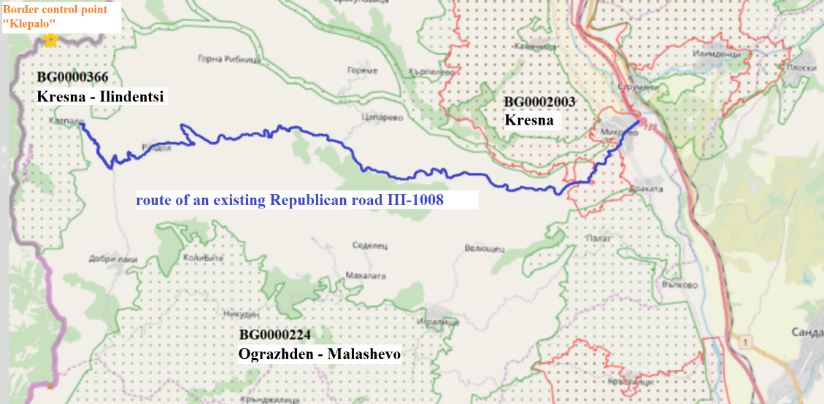

Figure 3-1 Location of the existing one lasts on the republican road III-1008 in relation to the protected areas in the region
Landscape
The foreseen measures and activities under the CBCP and TSIM are not expected to significantly affect areas with valuable /natural/natural landscape. The impact on the landscape as a whole is a complex positive of the landscaping measures - direct impact; energy efficiency and circular economy - indirectly; development of the family business, qualification - do not imply significant impact on the landscape; the development of alternative mobility systems - indirectly.
The development of tourism products and smart solutions for tourism using cultural and historical heritage sites have the potential to affect natural landscapes, so any such project should be subject to a preliminary assessment of the impact on the landscape - as part of the required procedures for environmental impact assessment. In this way, the protection of the natural resources and the value of the territory and compliance of the tourist load with the capacity of the environment should be ensured.
Tangible assets
The CBCP and TSIM projects foresee the implementation of targeted measures to improve the existing and build new modern and meet all environmental requirements and standards transport, communal, cultural and tourist infrastructure, as well as invest in the development and construction of alternative environmental systems and infrastructure for achieving a greener, low-carbon, competitive and connected region. In connection with the above, no significant negative impact on territories is expected in terms of tangible assets, but only a positive one.
Cultural-historical heritage
Non-construction activities do not have the potential to significantly affect and negatively affect cultural heritage sites.
Any construction activity has the potential to endanger previously unregistered archaeological cultural values, and to lead to the destruction or destruction of archaeological sites. The legislation of both countries provides for specific actions to be taken in the event of the discovery of such sites, and no significant adverse effects are expected in this regard. The measures related to specific objective 1.2 of TSIM are directly aimed at using the potential of the cultural and historical heritage for the development of tourist products, and a positive impact is expected - maintenance of these sites.
Harmful physical factors
With regard to harmful physical factors, the noise factor from road traffic is important for the cross-border region in the scope of CBCP and TSIM. Transport connections and connectivity between the Republic of Bulgaria: 2 NUTS III districts: Blagoevgrad and Kyustendil and the Republic of North Macedonia: 3 NUTS III districts: Northeast, East and Southeast, is presented in item 2.1.11 of the EAR.
The change in the noise load in the considered area may be influenced by the change in the transport and communication network, the emergence of new local sources of noise, etc., provided for in the CBCP and TSIM.
Important for the identification of the affected areas by the noise factor, the possible impacts as a result of achieving the objectives and priorities of the TCP and TSIM will be considered below.:
Priority 2 foresees the implementation of a strategic infrastructure project - opening of a new Klepalo border checkpoint - in the municipality of Strumyani, Blagoevgrad district, Bulgaria and Berovo municipality, Eastern region, Republic of North Macedonia. The road access to the new border checkpoint is planned to be realized from a class III road, part of the RRN. For the purposes of the assessment, data obtained on the basis of long-term measurements and calculations of the level of traffic noise on roads of different classes may be used, namely:
The equivalent noise level, Leq - dBA, emitted by the traffic flow (noise characteristic) is determined by the dynamic parameters of the flow - intensity (number of vehicles/hour), structure (percentage of heavy goods vehicles and buses in the total flow), speed (km/h) and parameters of the road route - pavement, longitudinal slope (%). At present, data on the indicated parameters of the traffic flow in the considered road sections are not presented..
The noise characteristics of the flow at a distance of 7.5 m from the axis of the nearby lane, depending on the class of the road are:
Class II - in the range of 65-70 dBA at a permitted speed of 80km/h;
Class III - in the range of 60-65 dBA at a permitted speed of 60 km/h
IV and V class - up to 60 dBA depending on the specific load and speed.
The existing section of road III-1008 passes through the villages of Mikrevo, Razdol and Klepalo. The new route of the road from km 22+000 (before the road deviation for the village of Kolibite) to the beginning of the site of Klepalo border checkpoint, its class and the set design speed - up to 40 km/h suggest low intensity of traffic flows, which implies equivalent noise levels below 50 dB (A) for the day and below 40 dB (A) for the night.
The implementation of the project does not imply an increase in noise exposure above the permissible norms and does not imply the emergence of health risk for the population in the area.
The implementation of the CBCP and TSIM is not expected to exacerbate existing problems or create new ones. The priorities and measures foreseen by the CBCP and TSIM do not imply a risk of additional noise pollution in settlements. The planned activities/measures for landscaping of urban and suburban areas (under Priority 1 of the CBCP) and improving the mobility and connectivity of transport and engineering infrastructure through the development of alternative mobility systems (measure 1.2.1. Of TSIM) will have positive effect for limiting the noise load and impact on the environment and the population of the region, included in the scope of CBCP and TSIM.
The priorities and measures foreseen by the CBCP and TSIM are not related to activities involving additional effects of vibration, ionizing and non-ionizing radiation.
Waste
Significant impact on the territories of waste activities is not expected, nor is it expected to generate significant amounts of waste in the implementation of eligible activities and measures, on the contrary - foreseen as eligible activities for technological modernization (to measure 1.1.1. Of TSIM) and for effective product development process (to measure 1.1.3 of TSIM) contribute to the transition to a circular economy and have a positive impact on reducing the amount of waste generated.
Hazardous chemicals and the risk of major accidents
The forecasts of the CBCP and TSIM are not associated with a significant impact as a result of storage and use of hazardous chemicals, and the eligible activities and measures do not have the potential to increase the risk of major accidents in existing enterprises with low and high risk potential within the cross-border area.
Population and human health
With regard to human health, the implementation of the CBCP and TSIM projections is not related to new, significant sources of emissions and environmental hazards that would lead to new or increase the adverse effects of identified existing risk factors in the cross-border area. On the contrary, the implementation of activities and measures is expected to have a positive impact related to improving the quality of life, the development of non-health activities - an object of income for the population (tourism), limiting the harmful effects of local production (through technological activities). modernization). It is extremely important that the location of new sites (eg the planned new road section as part of the strategic project under Priority 2 of the CBCP, etc.), which will be financed under the CBCP and TSIM, comply with the nearest areas and sites subject to health protection, as well as to ensure compliance with regulatory requirements for water protection and in particular the prohibitions and restrictions in the sanitary protection zones of water sources for drinking and domestic water supply and mineral waters used for therapeutic, prophylactic, drinking and hygiene needs. A detailed assessment of the expected impacts is presented in item 6 of the EC Report.

Taking into account the above, the assessment of the six environmental objectives to the principle of non-significant damage¹ to the activities and measures of the CBCP and TSIM allows us to draw the following conclusions:
      - Climate change mitigation: Most of the measures have a positive or no impact on reducing greenhouse gas emissions, and none of the measures and activities lead to significant greenhouse gas emissions - no significant damage is expected in terms of mitigation. climate change. The activities under Priority 1 of the CBCP have a direct positive impact on the absorption of greenhouse gas emissions, and the activities under measure 1.1.1 of TSIM for technological organization will lead to a reduction of greenhouse gas emissions of the respective enterprises. It should also be noted that green and digital solutions should be included as horizontal principles and thus become an integral part of all supported projects under the TSIM.;
      - Adaptation to the change of the climate: Most of the measures have a positive or no impact on reducing greenhouse gas emissions, and none of the measures and activities lead to significant greenhouse gas emissions - no significant damage is expected in terms of mitigation. climate change. The activities under Priority 1 of the CBCP have a direct positive impact on the absorption of greenhouse gas emissions, and the activities under measure 1.1.1 of TSIM for technological organization will lead to a reduction of greenhouse gas emissions of the respective enterprises. It should also be noted that green and digital solutions should be included as horizontal principles and thus become an integral part of all supported projects under the TEMP. current and projected future climate, population, nature or assets - - no significant damage is expected to be mitigated by climate change mitigation. Some of the measures and activities contribute to the adaptation and ensuring the sustainability of climate change - landscaping activities under Priority 1 of the CBCP;
      - Sustainable use and conservation of water and marine resources: The measures and activities will have an indirect positive effect on water, as no measures and activities are foreseen that would lead to deterioration of the quality or quantity of water, in compliance with the regulations for water protection.
      - Transition to a circular economy, prevention of waste generation and recycling: Some of the activities and measures contribute to the transition to a circular economy (under specific objective 1.1 of the TSIM). The remaining measures and activities under the CBCP and TSIM are not associated with a significant increase in the generation, incineration or disposal of waste, do not lead to significant inefficiencies in the direct or indirect use of natural resources and do not have the potential to cause long-term environmental damage. the circular economy.
5) Pollution prevention and control: Some of the measures and activities have a clear environmental focus, and they will contribute to limiting existing environmental problems. The projections of the CBCP and TSIM are mainly related to the improvement and development of existing sites, which will lead to their renovation, modernization, related to and limiting the impact on the environment.
Specific objective 1.1 of the CBCP is entirely environmentally oriented, incl. to reduce all forms of pollution, Specific Objective 2.1 and its strategic project contribute to the diversification of traffic and increase security, and Specific Objective 3.1 is relevant to the greening of existing SMEs.
When financing new sites and technical infrastructure (including the strategic project under Priority 2 of the CBCP), the availability of zones and sites subject to health protection and other sensitive areas should be taken into account - sanitary protection zones around water sources, protected zones. and territories, sites of cultural heritage, possible cumulative impact with existing facilities and infrastructure in the respective area. These impacts and their prevention or minimization will be subject to the statutory procedures for environmental impact assessment, environmental assessment, complex permit, permits under the Water Act, etc., which will ensure compliance only with projects that do not lead to a significant increase in emissions of pollutants into the air, water or land.
      - Protection and restoration of biodiversity and ecosystems: The principal nature of the activities that will be implemented under the CBCP and TSIM is such that it does not imply negative impacts (or at least significant ones) on biodiversity. Most measures and activities under the CBCP and TSIM are related to neutral to positive impacts on biodiversity. In compliance with the national laws and administrative acts of the two countries, which are aimed at protecting their biodiversity, the potential negative impacts of activities and measures of an investment nature will be reduced to acceptable limits. Measures and activities under CBCP and TSIM are not expected to lead to deterioration of the state and sustainability of ecosystems, or the conservation status of habitats and species, respectively, no significant damage is expected.
- Existing environmental problems identified at different levels related to the CBCP and TSIM, including those of areas of special ecological importance, such as protected areas under the Biodiversity Act
In item 4 of the Environmental Assessment Report an analysis is made of the existing environmental problems in the country, identified at different levels, related to CBCP and TSIM, incl. of the connection between the environmental problems and the envisages of the plan, respectively - conclusions whether CBCP and TSIM will lead to improvement of the ecological situation, or to aggravation and aggravation of existing ecological problems and/or emergence of new ones.
The analysis shows the presence of problems in almost all components and factors of the environment, as well as the possibility with the implementation of CBCP and TSIM to contribute to their limitation.
The forecasts of the CBCP and TSIM have no potential and are not expected to lead to the development of existing or the emergence of new environmental problems in the area.
- Environmental protection objectives at national and international level relevant to the CBCP and TSIM and the way in which these objectives and all environmental considerations have been taken into account in the preparation of the program and strategy
In Item 5 of the Environmental Assessment Report an analysis is made of how the environmental protection objectives identified in international, including European and national documents relate to the provisions of the CBCP and TSIM and whether and how the provisions of the CBCP and TSIM take them into account.
  - Integration of environmental protection objectives in the projects of CBCP and TSIM
The integration of environmental objectives into CBCP and TSIM is enshrined in the regulations for financial support for the period 2021-2027, which require a corresponding percentage of funds to be for activities and measures related to environmental protection.
In this regard, by default, CBCP and TSIM integrate environmental objectives at European and national level.
  - Environmental protection objectives at international and national level, relevant to CBCP and TSIM and the way in which they are complied with

In item 5.2 of the Environmental Assessment Report, in tabular form is presented an analysis of the relevance of environmental objectives at international and national level, included in some of the strategies, plans and programs described in item 1.4 of the EAR.
The performed analysis shows the following results:
- The foreseen activities under the TSG and measures under the TSIM are not in conflict with environmental protection objectives;
- CBCP and TSIM integrate the relevant environmental goals at national and international level and will contribute to their achievement. In particular, the CBCP and TSIM have integrated and foreseen measures and activities that will directly and indirectly contribute to the implementation of the objectives of strategic documents at national and European level for climate change mitigation, adaptation to climate change, conservation and sustainable water use, transition to a circular economy, pollution reduction and control, protection and restoration of biodiversity and ecosystems (environmental objectives within the scope of the principle of non-harm);
- Some environmental objectives are relevant to the stage of implementation of the CBCP and TSIM and should be taken into account in the preparation and implementation of project proposals.
- Likely significant effects on the environment and human health, incl. and transboundary environmental impacts in other countries
Item 6 of the EA report assesses the expected impacts of the implementation of the CBCP and TSIM on the environment and human health at the two levels that the programme and strategy identify (strategic level and level "measures/activities"), taking into account the nature of the interaction and synergy between the different impacts, namely: secondary, cumulative (considered in a separate point 6.3), concurrent, short-term, medium-term, long-term, permanent and temporary, positive and negative effects.
Strategic level:
  - For CBCP, this includes an assessment of the impact of the Priorities and Specific Objectives;
  - For TSIM, this includes an assessment of the impact of the Vision, the Strategic Objective and the Specific Objectives.
Level "measures / activities“:
  - For CBCP this includes an impact assessment of the activities/investments/strategic project supported;
  - For TSIM, this includes an impact assessment of the measures.
For the purposes of the Non-Technical Summary, summary information on the assessed impacts is presented:

  - Assess the likely impacts at the Strategic level

    - For CBCP
Priority, Specific objective | Summary of the impact
Priority 1 Greener border region (environmentally friendly infrastructure) | The priority is not related to negative, but to entirely positive, long-term impact on the components and factors of the environment.
Specific objective 1.1. Improving the protection and conservation of nature, biodiversity and environmentally friendly infrastructure, including in urban areas, and reducing all forms of pollution | The specific objective is not related to negative, but to entirely positive, long-term impact on the components and factors of the environment.
Priority 2 More connected border region (communication links, expanded access to the main TEN-T) | The priority and specific objective have a positive impact on most components and factors of the environment, as improved mobility and connectivity lead to traffic diversification, improved and facilitated traffic, increased safety and reduced risk of accidents, limiting emissions (compared to congested, low-traffic roads). Risks of adverse effects exist for the components and factors of the environment at the level of “specific project proposals / projects“
Specific objective 2.1. Development of climate-sustainable, intelligent and intermodal national, regional and local mobility, including improved access to TEN-T and cross-border mobility
Priority 3 Integrated development of the border region (integrated territorial development of the regions) | The integrated development of the border region is related to the exchange of information and experience, joint activities in compliance with a set of aspects (integration of activities), part of which is the protection of the environment and human health. A positive impact from the implementation of the priority is expected.

    - For TSIM

Vision, Strategic Objective and Specific Objectives | Summary of the impact
Vision: The CBC regions of the Republic of Bulgaria and the Republic of North Macedonia: a place for consolidation and stability of the cultural and historical heritage through joint efforts for mutually beneficial cooperation, socioeconomic cohesion and balanced sustainable development. | Integrated development, covering aspects of economic, social and environmental development, represents sustainable development, which is entirely positive for the environment and the health of the population in the region.
Strategic objective: Achieving integrated territorial development focusing on competitiveness and tourism development. | No significant negative impacts are expected.  The main indirect positive impact is expected from the increase of competitiveness, related to the improved condition of the enterprises of the local economy in comparison with their current condition, incl. emitting less harmful substances into the environment and improving the quality of life of the population.  The development of tourist products using the sites of cultural and historical heritage has the potential for negative impact on the air, soil, biodiversity and landscape, in case of non-compliance with the carrying capacity of the environment. The degree of this impact depends on the exact parameters, location and scale of the specific tourist product. In this regard, the choice for the development and realization of tourism products should be based on environmental impact assessment, and measures should be taken to prevent significant negative impacts. With regard to the other components and factors, the impact is from neutral to positive.
Specific objective 1.1. Increase the competitiveness of the local economy and improve the business environment:
Specific objective 1.2: Development of an attractive, all-season tourism product by means of smart solutions that ensure universal access and participation.

  - Assessment of the likely impacts at the level of "activities/measures"

    - For CBCP
А. Activities/investments subject to support under Priority 1:
Activities | Summary of the impact
Investments in construction of green areas (green balconies, green walls, green roofs, atriums, green pavements, green parking lots, green fences, noise barriers, etc.) | Overall positive impact for most components and factors of the environment. No impact is expected for the others
Investments in the development of green areas in urban and suburban areas, including improving the links between green areas (grass and street trees hedge, street green and green veins, green playgrounds /school playgrounds, green and flower squares, green shores)
Investments in the development of natural green urban areas (urban park, historical park /garden, small park /park, green space next door, institutional green space, green sports facility, forest, shrubs, abandoned and abandoned areas with wildlife areas)
Investments in the development of green areas for water management (rocks, restoration of hills and landscaping of nature, rain gardens or sustainable urban drainage systems (SUDS), naturalized reservoirs for torrential rains, bioretention areas) | A positive impact is expected, mainly related to improved water management and limiting the risk of floods without significant negative impacts.
Support for joint strategies and action plans for the development of new instruments, as well as for the transfer of decisions between relevant stakeholders | The development and subsequent implementation of strategies and plans has an indirect positive impact on the environment and human health, as a result of the selection of the best solutions, with a proven positive effect in the relevant field of application.

B. Strategic project supported by Priority 2:

Strategic project: Establishment of a new Klepalo border checkpoint between the Republic of Bulgaria and the Republic of North Macedonia ”
Environmental component / factor | Impact
Climate,  Climate change  Adaptation to the changing climate | The main adverse impact is during the construction phase of the sites and facilities, related to unorganized emissions of dust and exhaust gases from internal combustion engines of construction and transport equipment. The impact is local, temporary, reversible, so it cannot be assessed as significant.  Negative, local, prolonged, reversible, negligible and low impact of increased road traffic in the implementation of the new border checkpoint (BCP) "Klepalo" between the Republic of Bulgaria and the Republic of North Macedonia, given that the project (the only priority) will help to facilitate traffic between the two countries.  In terms of adaptation, the design of the project elements should take into account climate change impact forecasts in order to ensure the sustainability of the infrastructure.
Atmospheric air quality
Surface water  Groundwater  Water protection zones  Risk of flooding | No direct negative impact is expected on the legal use of surface water and wastewater discharge, as well as on protected areas for water, nor is an increase in the risk of floods expected.  When passing through water bodies, this should be done on the basis of the relevant permits for use of water bodies according to the applicable regulations.
Earth’s subsurface | No impact is expected. Neighboring areas affected by the construction should be recultivated by taking measures to prevent erosion processes and landslides/ landslides..
Soils  Land use | Direct negative local impact is expected, which will be short-term in compliance with the necessary activities and measures (as a result of EIA procedures) for the protection of soil resources in all phases - design, construction and operation.
Vegetation | Significant potential negative impacts on the components of biological diversity could be expected only from the implementation of activities related to the construction of new roads (leading to the Klepalo border checkpoint), to a much lesser extent than the rehabilitation of existing ones, as well as future intensive traffic on them (as a result of the integrated development of the region). The route of road III-1008 Strumyani - Klepalo border checkpoint, in the border area of ​​the village of Klepalo passes through BG0000366 BG "Kresna-Ilindentsi" under the Habitats Directive. With a letter Ex. № EC-17 / 29.06.2021 with regard to the requirements of Article 31 of the BDA, the competent authority has assessed that in general the Cross-border Cooperation Program 2021-2027 between Bulgaria and Republic of North Macedonia and TSIM at this stage is unlikely to negative impact on natural habitats, populations and habitats of protected species in Natura 2000 protected areas. the nature in both countries (specifically for Bulgaria EPA, Ordinance on the terms and conditions for carrying out EIA, BDA, Ordinance on AC, PTA) can be assessed as:  Manner and degree of impact: Negative, direct (when building new roads) and indirectly (when increasing road traffic), largely reversible with effective implementation of environmental legislation, weak to moderate within acceptable limits.  Territorial scope of impact: Within the territorial scope of the program within the limits of the road infrastructure subject to rehabilitation and completion and to a lesser extent in its neighboring territories);  Duration of impact: Temporary and short-term during the rehabilitation and completion of the road infrastructure, long-term and periodic from the traffic on it (especially in the light part of the day).
Animal world
Protected territories  Protected Areas | In the area of ​​the territory of the Republic of Bulgaria, near the Klepalo border checkpoint, there are protected areas under the Birds Directive and the Habitats Directive. Protected area BG0000366 "Kresna-Ilindentsi" under the Habitats Directive is expected to be affected by the route of the new road section to the border checkpoint. The impact assessment, incl. on the subject and objectives of the protected area will be subject to the environmental impact assessment procedure within the meaning of Directive 2014/52/EU of the European Parliament and of the Council of 16 April 2014 amending Directive 2011/92/EU on assessment the impact of certain public and private projects on the environment and an assessment of compatibility within the meaning of the Habitats Directive, these assessments being part of the scope of the strategic project.
Landscape | ransport infrastructure sites are associated with changes in landscape dominants. All activities related to the construction of transport infrastructure have a combined, complex, cumulative impact on the local landscape.  The operation is mainly related to visual impact.
Tangible assets | The project is related to the construction of a specific infrastructure site, the purpose of which is to improve regional connectivity and stimulate economic growth in the cross-border region by providing a new transport link to alleviate growing trafficking in human beings and goods, strengthen communication links, improve and expand access. to the TEN-T network.  The implementation of the project will have a significant direct positive impact on the materials assets, in terms of rehabilitation of existing infrastructure and construction of new ones that meet all environmental requirements and standards, both national (both partner countries) and EU level. . The project may require ownership and land regulation procedures. Its implementation should be in full compliance with the national laws of the partner countries in the field of spatial planning.  Prior to the implementation of the investment project, the respective will be subject to EIA procedures and compatibility assessment, according to the applicable legislation of both countries.
Cultural-historical heritage | Prior to the start of construction, it is necessary to conduct field research in which to locate the endangered archeological sites along the route of the new road section. Then, before the start of the construction works, rescue excavations must be carried out on all sites that will be affected by the construction (in case such are found). In the process of construction activities there should be observation by archaeologists along the entire route.  Exploitation is not related to the impact on cultural heritage.
Harmful physical factors | The project is related to the generation of noise from construction and transport equipment during construction activities. The impact is temporary and reversible, and therefore insignificant.  The class of the road and the set design speed - up to 40 km/h during its operation, suggest low intensity of traffic flows, therefore the expected equivalent noise levels will be below 50 dB (A) for the day and below 40 dB (A) for the night.  The implementation of the project does not imply an increase in the noise load above the permissible norms. No health risk is expected for the population in the area.
Waste | The project is mainly related to the generation of construction waste during the construction of sites and subprojects. Operation is not related to waste generation. The impact is insignificant in compliance with the current legislation on waste management.
Hazardous chemicals and risk of major accidents | The project does not require the use/storage/use of significant amounts of hazardous chemicals. The risk of accidents in the nearest enterprises with low and high risk potential is not expected to increase.
Population  Human health  Risk of accidents | Short-term and temporary impact on the site workers during the construction process - increased levels of dust and exhaust gases from internal combustion engines, noise and local vibrations from the construction and transport equipment used. The impact is reversible, and localized within the boundaries of construction sites and routes. Depending on the distance to sites subject to health care, discomfort is possible for the nearby population. In the framework of the EIA procedure, if necessary, route options should be considered and measures should be proposed to prevent significant impact on the population in the area of ​​the site.  For the stage of operation the main possible risk factor for disturbing the comfort of the population when crossing the route near populated areas and sites subject to health protection is acoustic noise, as according to the assessment of harmful physical factors made in the table above, no exceedances are expected for areas with normalized noise regime.
Summary of the impact:
For the project there is currently no EIA and AC procedure, and based on the available details it can be assumed, based on similar projects, that insignificant negative impact is expected during construction, locally, largely reversible, without cumulative nature. Operation is associated with negligible negative to neutral effects for some components and environmental factors.

    - For TSIM
А. Measures to Specific Objective 1.1.

Measures | Summary of the impact
Мeasure 1.1.1. Actions aimed at increasing the productive capacity of the SMEs to become greener, more digital and more competitive (technological modernization); | In general, indirect, long-term, positive impact of technological modernization. For the new activities and the related sites, the normatively required preventive EIA procedures and compatibility assessment should be performed..
Measure 1.1.2 Actions aimed at increasing the productive capacity of the SMEs to become greener, more digital and more competitive (technological modernization); | The measure does not have a direct impact on the environment and human health. No indirect negative impacts are expected.  Indirect positive impact is expected as a result of increased knowledge and acquired key skills related to focusing and investing in more environmentally friendly activities, increased environmental friendliness, circular economy and resource efficiency.
Measure 1.1.3 Actions aimed at building effective product development process (it encompasses all steps needed to take a product from concept to market availability) and reaching new markets (marketing, entrepreneurship, internationalization); | As there are no specific parameters at this level of detail and specific projects identified, the potential risk of negative impacts cannot be assessed. Projects of investment nature are subject to the regulated preventive procedures under the environmental legislation of both countries.

Б. Measures under Specific Objective 1.2.
Measures | Summary of the impact
Measure 1.2.1. Improving the mobility and connectivity of the transport and engineering infrastructure by a system of alternative mobility, including a grid of bicycle lanes, ‘dirt’ forest and country roads, helipads, etc.; | The impact is generally positive, as the alternative movement is more environmentally friendly than the traditional one - with vehicles related to the removal of significant areas, noise, emissions of harmful substances, incl. greenhouse gases, more significant impact on biodiversity.  However, the specific location and manner of implementation of the measures under the measure should be preceded by an assessment of the possible impact, in particular on water, soil, biodiversity, protected areas and zones, in order to avoid significant adverse effects..
Measure 1.2.2. Development and marketing of integrated regional tourism products suitable for various activities through the inclusion of the cultural and historical heritage and natural assets; joint efforts for diversification of the forms of tourism services and the realization of all-season tourism in the CBC region; | The development of tourist products using the sites of cultural and historical heritage has the potential for negative impact on the air, soil, biodiversity and landscape, in case of non-compliance with the carrying capacity of the environment. The degree of this impact depends on the exact parameters, location and scale of the specific tourist product. In this regard, the choice for the development and realization of tourism products should be based on environmental impact assessment, and measures should be taken to prevent significant negative impacts at the level of "project proposals". With regard to the other components and factors, the impact is from neutral to positive
Measure 1.2.3 Development of integrated targeted financial packages for supporting business activity and the creation of new SMEs in tourism with a focus on family businesses and the offering of local tourism products: wine and gourmet tourism, rural eco-tourism, cycling tourism, hunting and fishing, off-road tourism, etc.; | Similar to measure 1.2.2, there is a risk of negative impact on water
Measure 1.2.4 Creating a joint network of locations for the realization of concepts like ‘green school’, ‘in the country’, ‘visiting with...’, ‘made by...’, etc.; | Similar to the impact of TSI Specific Objective 1.2, the development of the tourism products listed in the measure has the potential for negative impacts on air, soil, biodiversity and landscape in case of non-compliance with the absorption capacity of the environment. The degree of this impact depends on the exact parameters, location and scale of the specific tourist product. In this regard, the choice for the development and realization of tourism products should be based on environmental impact assessment, and measures should be taken to prevent significant negative impacts at the level of "project proposals".  With regard to the other components and factors, the impact is from neutral to positive.
Measure 1.2.5 Elaborating and applying joint measures for reducing the vulnerability of services in the tourism sector to the effects of pandemic and epidemic situations; promoting the development of health and recreational tourism: products and services related to physical exercise, outdoor sports, strengthening the immune system and improving the health status through spa procedures, climate therapy, mud therapy; combining short breaks of different kinds with individual travel; | Similar to the impact of TSI Specific Objective 1.2, the development of the tourism products listed in the measure has the potential for negative impacts on air, soil, biodiversity and landscape in case of non-compliance with the absorption capacity of the environment. The degree of this impact depends on the exact parameters, location and scale of the specific tourist product. In this regard, the choice for the development and realization of tourism products should be based on environmental impact assessment, and measures should be taken to prevent significant negative impacts at the level of "project proposals".“.  With regard to the other components and factors, the impact is from neutral to positive.  Activities to reduce the vulnerability of services due to pandemic and epidemic situations will have an additional positive effect on the population, as in this way it is expected to guarantee income for the population in such periods, ie. to prevent the deterioration of the economic situation, hence the well-being and quality of life of those employed in the sectors affected by such situations

  - Cumulative impact
With regard to atmospheric air, no negative cumulative impact is expected - negative effects for some of the activities and measures related to construction are local and reversible..
Positive cumulative effect is expected in terms of climate from the implementation of activities and measures for green space development, technological renewal, resource and energy efficiency, pollution control and transition to a circular economy, as they are related to reducing and absorbing emissions. greenhouse gases. CBCP and TSIM do not include activities that alone or in combination lead to significant greenhouse gas emissions. A positive cumulative effect is also expected with regard to the adaptation to the changing climate from the implementation of the mentioned activities and measures with a favorable impact on climate change.
No significant negative cumulative impact on water is expected at the Strategic Impact Assessment Level. Regarding the indicative activities, insignificant negative cumulative impact can be expected on the water protection zones - the sanitary protection zones for drinking water.
In the process of implementation of CBCP and TSIM there will be positive cumulative impacts on surface waters as a result of the activities under Priority 1 of CBCP and the measures for technological modernization under TSIM.
The implementation of CBCP and TSIM may be accompanied by weak negative cumulative impacts on surface waters. These impacts are expected to occur mainly during the construction of the facilities.
The development of the regional infrastructure may have weak cumulative negative impacts on the places of water protection according to art. 119 of the Water Act. They refer to future projects that will be developed under the CBCP and TSIM. The combination of negative and positive weak effects may have a weak cumulative effect on the quantitative state in the same surface water body in:
-Simultaneous execution of construction works foreseen by strategic goals, investment priorities, visions and measures - Priority 1 - green areas from the CBCP and measures 1.2.1 and 1.2.3 of the TSIM;
- Simultaneous operation of existing and newly built plumbing facilities.
The forecasts for the level of strategic objectives, investment priorities and specific objectives do not envisage significant negative, cumulative negative impacts on surface waters, water protection zones and flood risk.
With regard to groundwater, no impact is expected, incl. cumulatively.
In the process of implementation of some activities and measures under CBCP and TSIM there will be positive cumulative impacts on soils - Priority 1 - green areas of CBCP and measure 1.1.1 of TSIM).
The implementation of CBCP and TSIM may be accompanied by weak negative impacts on soils. These impacts are expected to occur mainly in the course of construction of facilities and sites:
- Simultaneous execution of construction works on project proposals and other investment proposals;
-Simultaneous operation of existing and new buildings, facilities and infrastructure.
Forecasts for the level of strategic objectives, investment priorities and specific objectives do not anticipate significant negative, cumulative negative impacts on land and soil.
With regard to biodiversity, adverse cumulative impact is possible in all activities and measures related to the construction of new areas - the degree depends on the specific project proposal, its parameters, location, scale. A negative cumulative effect is also possible as a result of the development of new tourist products in places where there is already a tourist flow. The forecast for cumulative impact on the landscape is similar.
With regard to protected territories, cumulative impacts are possible, similar to those for biodiversity.
No cumulative effect is expected on protected areas due to the stricter management regime in them, namely a ban on construction.
With regard to the noise factor, the expected impact is defined as positive, cumulative. No negative cumulative effect is expected for the region under consideration, incl. occurrence of health risk for the population in the area from the action of noise. With regard to other harmful physical factors, no impact is expected, incl. cumulatively.
No cumulative negative impact is expected for cultural heritage sites.
With regard to tangible assets, a positive cumulative impact is expected to improve the condition of existing tangible fixed assets and / or build new environmentally friendly ones in the cross-border area, as through specific eligible activities and measures aimed at transport, cultural, tourism, urban, communication , digital and environmental infrastructure will ensure stable regional mobility and connectivity, which in turn will have a direct impact on increasing the competitiveness of the region as a whole. No negative cumulative effect is expected.
With regard to waste, a positive cumulative impact is expected for waste management in the cross-border area, as specific eligible activities and measures for cleaning up pollution and the circular economy will improve waste management in general. No negative cumulative effect is expected.
With regard to hazardous chemicals and the risk of major accidents, no cumulative impact is expected.
The forecasts of CBCP and TSIM are generally with hazardous chemicals and the risk of major accidents a positive effect on human health and health and hygiene aspects of the environment. Negative cumulative effect is possible in the implementation of new, albeit high-tech production and activities in areas with already busy production environment, near areas and sites subject to health protection, or leading to a secondary significant increase in transport traffic through settlements, as well as in case of non-compliance with the tourist capacity of the destinations in which tourism will be developed under specific objective 1.2 of TSIM.

  - Transboundary impact of CBCP and TSIM
Regarding the likely transboundary impact as a result of the implementation of the CBCP and TSIM:
- CBCP and TSIM are cross-border in nature and scope, and both documents aim to have an impact on the scope of the defined cross-border region. In this regard, by preparing this common ЕАР for the whole territory within the scope of the program, the impact of the envisages of the two documents in the cross-border region has been assessed by default.;
- With regard to transboundary impact within the meaning of the Protocol on Strategic Environmental Assessment to the Convention on Environmental Impact Assessment in a Transboundary Context, the EAR will analyze the likelihood of transboundary impact on the territory of other countries, outside the cross-border region - subject to CBCP and TSIM. At this stage, taking into account the projections of the draft program and the strategy, there is no reason to assume a cross-border impact on the nearest neighboring countries - the Republic of Serbia and the Hellenic Republic..

  - Summary of the impact

Strategic level
With regard to atmospheric air, the impact at the strategic level is generally positive, indirect and direct compared to the impact in the cross-border area at present. Minor negative impact with low degree, local, long-term, reversible, is expected from the goals and priorities related to the development of connectivity (road network) and tourism.
With regard to climate change, projections at the strategic level are not linked to significant greenhouse gas emissions, on the contrary - most targets and priorities are related to limiting these emissions.
With regard to adaptation to climate change, the goals and priorities are not related to increasing the vulnerability of climate change - on the contrary, some of the goals and priorities are related to ensuring climate sustainability (Priority 1 of the CBCP, Specific Objective 1.1 of TSIM, etc. .). Predictions are not related to the impact on people, assets or nature. Specific requirements for climate resilience / adaptation should be integrated into project proposals.
There are no forecasts, incl. activities and measures related to the generation of significant greenhouse gas emissions or those leading to a conflict/conflict or reducing the effectiveness of adaptation measures.
In terms of surface water, water protection and flood risk areas predominate:
- absence of negative impact, both directly and indirectly;
-presence of positive impact in most cases;
-long-term and in most cases - permanent impact.
In terms of soils and lands, they predominate:
-absence of direct negative impact. An exception is the potential indirect (indirect) negative impact on lands and soils in the process of their use with the development of the tourist product;
-presence of positive impact in most cases;
-long-term and in most cases - permanent impact.
Most projections have a neutral to positive impact on biodiversity, protected areas and territories. The potential for adverse effects are projections related to improving the mobility / connectivity and development of all-season tourism products - the degree of impact and eligibility of these activities depends on the parameters of specific projects and should be assessed in their planning / design. The impact on the landscape is similar.
An entirely positive long-term impact is expected in terms of tangible assets and cultural and historical heritage.
With regard to the noise factor, the expected impact is defined as positive, cumulative, simultaneous, long-term and permanent for the region under consideration. With regard to other harmful physical factors, no impact is expected.
With regard to waste, a positive, indirect and direct long-term impact is generally expected.
Indirectly positive and long-term, cumulative within the program and strategy, is the impact on the population and human health at the Strategic level.
With regard to the earth's subsurface and hazardous chemicals and the risk of major accidents, no impact is expected.

Level "activities / measures“
With regard to air and climate change, a generally positive, indirect and direct long-term impact is expected, with the exception of tourism development measures, as well as during the construction of all types of engineering and transport facilities and sites.
In terms of surface water, water protection and flood risk areas predominate:
-absence of direct negative impact, in very rare cases - indirectly;
-presence mainly of direct and indirect positive impact;
-long-term and in most cases - permanent impact;
- in most cases there is no impact at all.
No impact on the earth's subsurface and groundwater is expected.
With regard to lands and soils, the following predominate:
- Existence of potential direct short-term negative impact for TSIM on the measures related to the improvement of mobility and development of tourism;
-presence mainly of direct and indirect positive impact;
-long-term and in most cases - permanent impact;
- in most cases there is no impact at all.
Different in terms of manner and degree of negative impacts on biodiversity as a result of the implementation of the CBCP could be expected as a result of the implementation of the strategic project under Priority 2 of the CBCP and some of the measures under specific objectives 1.1 and 1.2 of TSIM. At the same time, some positive impacts can be expected - mostly from the activities under Priority 1 and to some extent under the strategic project under Priority 3. Given this, in the implementation of all future activities in accordance with national laws, regulations and administrative acts of the two countries, which are aimed at conserving biodiversity and nature in them, the potential negative impacts will be reduced to acceptable limits.
Negative impacts are expected for measures related to the development of tourism and mobility, and each project proposal should be subject to an environmental impact assessment and the objectives and subject of protected areas, in accordance with the applicable legislation of both partner countries. The impact on the landscape is similar.
The impact on the sites of cultural and historical heritage from the measures for development of tourism based on such sites is positive, for the other measures no impact is expected.
With regard to the noise factor, the expected impact is generally defined as positive, cumulative, simultaneous, long-term and permanent for the region under consideration, without preconditions for the occurrence of health risk for the population in the region. With regard to other harmful physical factors, no impact is expected.
With regard to waste, an overall positive impact is expected as a result of the specific waste activities and measures foreseen. No negative effects are expected from the other measures.
No negative impact is expected with regard to hazardous chemicals and the risk of major accidents.
The impact on the health and hygiene aspects of the environment is generally positive. The location of new production sites should take into account the proximity to areas and sites subject to health protection, in order to prevent harmful effects on human health in these areas and sites.

- Foreseen measures to prevent, reduce and compensate as fully as possible the adverse effects of the implementation of the CBCP and TSIM on the environment and human health
The analyzes and the assessment of the expected impact in the implementation of the CBCP and TSIM require the identification of measures, the implementation of which will ensure the prevention, limitation and as full compensation as possible of the adverse effects on the environment and human health. The measures are motivated by the expected results of their implementation:
  - Measures to reflect in the final versions of the CBCP and / or TSIM
The implementation of CBCP and TSIM does not imply significant negative impacts on the environment and human health, therefore measures to reflect in the final version of CBCP and TSIM are not necessary.

  - Implementing measures for the implementation of CBCP and / or TSIM
General measures:
- Plans, programs, projects and investment proposals arising from CBCP and TSIM falling within the scope of Directive 2014/52 /EU or Directive 2001/42 /EC or outside them and falling within the scope of Article 6 of Directive 92/43 /EEC, are subject to assessment for their compatibility with the subject and objectives of protection of protected areas and can be approved only after a decision/opinion on EAR/EC/EA for approval/coordination, and in accordance with the recommendations of the assessments, and with the conditions, requirements and measures set out in the decision/opinion.
Expected result: Prevention of significant adverse effects on the environment and human health, the subject and objectives of protection of protected areas.
- Investment proposals arising from measures and activities under the CBCP and TSIM to comply with the existing spatial plans of the territory, as well as national, regional and local strategic, planning and regulatory documents, other available planned projects with similar and/or convergent activities in order to achieve the necessary synchronization in the implementation of project procedures by the involved institutional bodies.
Expected result: Avoidance of contradictions, according to the current legislation and the already adopted strategic and planning documents. Preventing project proposals that do not comply with existing ones, leading to administrative difficulties and/or requesting double funding for overlapping activities.
Atmospheric air
- Priority approval for realization of production activities / technological modernizations, corresponding to the best available techniques.
Expected result: Ensuring production with minimal emissions of harmful substances into the atmosphere
.

Adaptation to climate change
- Consideration of the relevant activities and measures from the current strategic documents for adaptation to climate change and provision of measures to ensure the sustainability of projects.
Expected result: Ensuring climate resilience of projects.

- When developing project proposals under specific objective 1.2 of the TSIM, the consequences of climate change should be taken into account, incl. forecasts for water scarcity, risk of forest fires, floods and other adverse weather events, ensuring the sustainability of tourism infrastructure and sites.
Expected result: Ensuring climate resilience of projects.

Waters, water protection zones and flood risk
- For the projects to be provided measures for prevention of the deterioration of the condition of the surface waters and zones for protection of the waters, according to the requirements of art. 116 of the Law on Waters of the Republic of Bulgaria as well as the Law on Waters of the Republic of North Macedonia
- Investment proposals, plans and programs to be implemented in accordance with the current River Basin Management Plans, Flood Risk Management Plans and the legislation on water protection and management.
Expected result of measures 6 and 7: Prevention of deterioration of surface waters and water protection zones, as well as increase of flood risk.
- Sustainable use of water, incl. introduction of revolving cycles for water use in industrial enterprises, local treatment of industrial wastewater.
Expected result: Protection of the chemical and ecological condition / potential of the surface waters.
- Taking measures and technological solutions to prevent accidental pollution of surface waters.
Expected result: Protection of the chemical and ecological condition/potential of surface and groundwater.
- Carrying out periodic reclamation of "black" forest and field roads and "off-road" routes.
Expected result: Protection of the territories from erosion and the impact on the surface waters.
- Prevention of accidental surface water pollution;
Expected result: Protection of the chemical and ecological condition/potential of the surface waters.

Soils
- In the design of the new sites to include the necessary activities and measures for protection of soil resources and reclamation in order to prevent the occurrence of erosion processes and maximum restoration of the disturbed lands.
Expected result: Prevention of impact on lands and soils during the implementation of design decisions.
- During the implementation of the construction activities it is necessary to take measures for protection of the soil resources (preliminary seizure of the humus soil and its utilization for the purposes of reclamation.
Expected result: Conservation of soil resources.

Vegetation, fauna, protected areas and protected territories, landscape
- In the planned measures for construction of green areas under Priority 1, specific objective 1.1 of the CBCP not to use invasive alien species.
Expected result: Preservation of the local vegetation and related habitats of the region and prevention of its displacement by alien and invasive species.
- In case of project proposals for hunting and fishing activities within the scope of measure 1.2.3. under TSIM should be carried out in accordance with the Hunting Act, the by-laws to it and in coordination with the local hunting teams.
Expected result: Avoidance of significant negative impact on biodiversity.
- The development of tourism products related to off-road tourism should be consistent with the regimes of protected areas and protected territories in the region, more than 1/3 of which in its Bulgarian part is covered by protected areas under the Habitats Directive and in more a small degree of protected territories under the Birds Directive. Their scope should be applied and observed compliance with the ban on the movement of motorcycles, ATVs, UTVs and buggies outside the existing roads in non-urban areas (does not apply to designated on the basis of regulations routes for the movement of these vehicles, and in case of disasters, emergencies and for fire, emergency, control and rescue activities) ", as well as the ban on conducting motor racings off the existing roads” .
Expected result: Avoidance of significant negative impact on biodiversity.
- Measures and projects for development of tourism to be implemented in accordance with the norms for recreational load and absorption capacity of the environment, and taking into account the status of the territory.
Expected result: Prevention of significant load on the territory, incl. destruction of valuable landscapes, elements of biological diversity, habitats of species, soils.
Hazardous chemicals and risk of major accidents
- In case of construction of a new or alteration in an existing enterprise and/or facility with low or high risk potential, as well as in the planning of new constructions, including the construction of transport roads, residential areas, public facilities nearby to existing enterprises and/or facilities with low or high risk potential, where the location or new constructions may be a source or increase the dangers or consequences of a major accident in these enterprises/facilities, it is necessary:
  - Ensuring safe distances of the enterprise and/or facility to residential areas, public sites and areas, recreation areas and, where possible, major transport routes.
  - Maintaining safe distances of enterprises and/or facilities with low or high risk potential or other appropriate measures to areas of special conservation sensitivity or interest and sites of cultural and historical heritage in the vicinity of enterprises, where appropriate, in order to protect them.
  - Taking additional technical measures to limit the risks to human health and the environment, in the case of existing enterprises and / or facilities with low and high risk potential
Expected result: Avoidance of risks associated with major accidents involving hazardous chemicals.
Population, human health, health and hygiene aspects of the environment
- When planning and implementing investment proposals, the location of the sites shall be in accordance with the expected emissions of harmful substances in the environment and the living environment and the availability of sites subject to health protection, as well as zones and territories where such sites are located.
Expected result: Prevention of risks and protection of the population and human health.
- Reasons for choosing the considered alternatives
The projects submitted by the Assignor to CBCP and TSIM do not contain alternatives.
The analysis of the "zero alternative", made in item 2.2 of the EAR, shows that it has a less favorable impact than the alternative for the implementation of the program and the territorial strategy to it.
The alternative for the implementation of CBCP and TSIM. is generally with a complex positive impact on the environment, incl. on the population and human health, as the eligible activities and measures are predominantly environmental oriented. However, some of the planned activities are related to possible negative impact, therefore at the stage of implementation and implementation of CBCP and TSIM must be implemented the recommended measures in item 7 of the EAR, as well as all laws and regulations in force. in both countries related to the protection of individual components of the environment, incl. human health.
- Methods for carrying out the ecological assessment, used normative base and documents and difficulties in gathering the necessary information
Item 9 of the Environmental Assessment Report describes the methodology of preparation of the report and the used basic methodological documents, regulations and sources of information, incl. difficulties in gathering information
The report was prepared according to the following methodological approach:
- Familiarization of the team of experts with the projects of CBCP and TSIM and their forecasts, the other documentation provided by the Contracting Authority, the opinions on the terms of reference for determining the scope and content of the Environmental Assessment Report;
- Identification and analysis of other plans, strategies and programs related to the projects of CBCP and TSIM;
- Collection, analysis and processing of literature sources and data on the current state of the environment by components and factors, its relationship with the current level of development of the cross-border area in the scope of CBCP and TSIM;
- Analysis of the development of the environment in case of non-application of CBCP and TSIM“);
- Analysis of the probable significant impact on territories with CBCP and TSIM;
- Collection, processing and analysis of information on the existing environmental problems at the national level and their connection with the CBCP and TSIM, incl. possible development of these problems with and without the implementation of CBCP and TSIM;
- Analysis of the extent to which the CBCP and TSIM projects comply with the relevant objectives and measures for environmental protection, included / identified in documents - plans, strategies and programs at national and international level;
- Analysis and assessment of the impact of CBCP and TSIM on the environment: As CBCP and TSIM are strategic documents, the assessment of the likely significant impacts on the environment and human health has been carried out on two levels of detail ("strategic" and "measures/activities“);
- Proposing measures to prevent, reduce and limit impacts, as well as measures to monitor and control the impact of the program in the implementation and;
- Motivated choice of the most appropriate alternative in terms of impact on the environment and human health;
- Preparation of a motivated conclusion for the implementation of CBCP and TSIM.
- Measures in connection with the monitoring during the implementation of CBCP and TSIM

According to the results and conclusions of the forecasts for the impact of CBCP and TSIM on the environment and human health, item 10 of the Environmental Assessment Report proposes measures and indicators on the basis of which to monitor and control projected possible significant, as well as possible unforeseen negative impacts when applying them.
The proposed measures are given in the following table:

Table № 10-1 Measures for monitoring and control of the impact on the environment and human health in the implementation of CBCP and TSIM
№ | Monitoring and control measure | Indicators | Period / Responsible authority for implementation
 | For measures and activities of an investment nature to comply with the relevant objectives, guidelines and measures for adaptation to climate change to ensure their sustainability | Sustainability measures foreseen in the project proposals | When approving project proposals /Governing body, National body
 |  | Cases of damage to sites, facilities or infrastructure by extreme events - the result of climate change | After commissioning/Beneficiaries
 | Prevention of deterioration of the condition of water bodies during the implementation of project proposals of investment nature in the vicinity of such sites, or related to the use/impact of water bodies | Surface and/or groundwater monitoring data, if prescribed by the competent authorities for the specific project proposal | During construction and operation in accordance with the periodicity specified in the plan for own monitoring/Beneficiaries
 | Admissibility of project proposals of investment nature compared to the current RBMPs and FBMPs. | Existence of an opinion from the competent authorities | Before the start of the project/  Beneficiaries
 | Prevention of water pollution in emergency situations | Preventive measures foreseen | During the preparation of the project proposal/Beneficiaries
 |  | Number of emergencies - actions taken | Periodically/Beneficiaries
 | Observance of the adopted management regimes of the protected areas, including limitation of the probability of negative impact on the protected areas and the priorities of protection in them | Approved investment projects on the territory of protected areas, occupied area (decares);  Manner of compliance with management regimes . | Periodically/Beneficiaries
 | Prevention of disturbance/damage/ destruction of valuable plant species, as well as animal species and their habitats | EIA/EC/AC procedures carried out (where applicable) | Periodically/Beneficiaries
 | Prevention of damage/violation/ destruction of cultural values - archaeological sites in the construction of sites and infrastructure | Implementation of the measures from the final acts on EIA /EC/AC (when they are provided for biodiversity) | Before starting the construction activities/Beneficiary
 |  | Existence of a competent, authorized person during the construction | During construction/Beneficiary
 | Prevention of exceeding the noise levels for projects that are implemented in/near areas with normalized noise regime | Measured noise values dB (A) compared to the permissible norms . | According to the established periodicity in the plan for own monitoring and/or by the Decision on EIA/Beneficiaries

- Conclusion of the environmental assessment
Based on the analyzes, forecasts and assessments made, the impact of the implementation of the CBCP and TSIM, in the implementation of the recommended measures in item 7 of the EA Report is:
In general, with regard to atmospheric air and climate change, a positive impact is expected as a result of specific eligible activities and measures under the CBCP and TSIM. The forecasts of CBCP and TSIM do not have the potential for significant negative impact, but only for temporary local, reversible impact. No activities and measures are foreseen that would lead to a significant increase in greenhouse gas emissions.
Some of the planned activities (green areas, resource and energy efficiency, technological renewal of production, transition to a circular economy) have a direct positive contribution to limiting climate change and adapting to changing climate. No activities and measures are foreseen that would pose a risk to the population, nature or assets based on climate change forecasts and the consequences thereof..
With regard to water, incl. the zones for water protection and flood risk - based on the performed ecological review of CBCP and TSIM Republic of Bulgaria –Republic of North Macedonia 2021 - 2027, through the analysis and assessment of the potential impacts of the activities foreseen under the respective priority axes, goals and visions, concludes that the Program and the Strategy will have an overall positive impact at regional, national and cross-border level, as most of the indicative activities and measures foreseen directly or indirectly contribute to improving the status of surface waters, water protection zones and the risk of floods, and in general - the environment. No impact on groundwater is expected. The activities and measures included in the CBCP and TSIM do not have the potential to violate the good status and good environmental potential of water bodies.
No impact on the earth's subsurface and groundwater is expected.
Based on the conducted environmental review of CBCP and TSIM, through the analysis and assessment of the potential impacts of the activities foreseen under the respective priority axes, objectives and visions, the conclusion is that the Program and Strategy will lead to overall positive impact on regional, national and cross-border level, as most of the indicative activities and measures foreseen directly or indirectly contribute to improving the condition of soils and the environment in general.
Most projections are expected to have a neutral to positive impact on biodiversity and protected areas and territories. Negative impact is expected mainly in the measures related to the development of tourism and mobility, and in the construction of new enterprises in non-urban areas, and each project proposal should be subject to environmental impact assessment and the objectives and subject of protected areas. in accordance with the applicable legislation of the two partner countries. The impact on the landscape is similar.
The impact on the cultural heritage is positive for the measures related to the development of cultural tourism and neutral for the other forecasts.
With regard to the noise factor, the expected impact is defined as positive, cumulative, simultaneous, long-term and permanent for the region under consideration. The forecasts of CBCP and TSIM do not have the potential for significant negative impact, incl. creating a risk to human health.
With regard to other harmful physical factors, no impact is expected.
With regard to waste, a positive impact on its management is expected as a result of specific eligible activities and measures under the CBCP and TSIM. The forecasts of CBCP and TSIM do not have the potential for significant negative impact. The activities and measures are not related to the generation of significant amounts of waste, incl. dangerous.
With regard to hazardous chemicals and the risk of major accidents, the CBCP and TSIM forecasts do not include new companies, nor do they have the potential to increase the risk of major accidents in existing companies with low and high risk potential..
The impact on the population, human health and health and hygiene aspects of the environment is complex positive, related to the favorable impact of socio-economic factors in the region and environmental factors related to health.

Given the above, the implementation of CBCP and TSIM is preferred in terms of environmental and human health impact over the "zero" alternative.
- Given the above, the implementation of CBCP and TSIM is preferred in terms of environmental and human health impact over the "zero" alternative

Item 12 of the Environmental Assessment Report presents information on all opinions received as a result of the consultations held at the previous stage of the environmental assessment procedure under the Terms of Reference for determining the scope and content of the Environmental Assessment Report..
Opinions and their manner of compliance with the reasons for this are presented in Table 12-1 to item 12 of the Environmental Assessment Report.

