TERRITORIAL STRATEGY

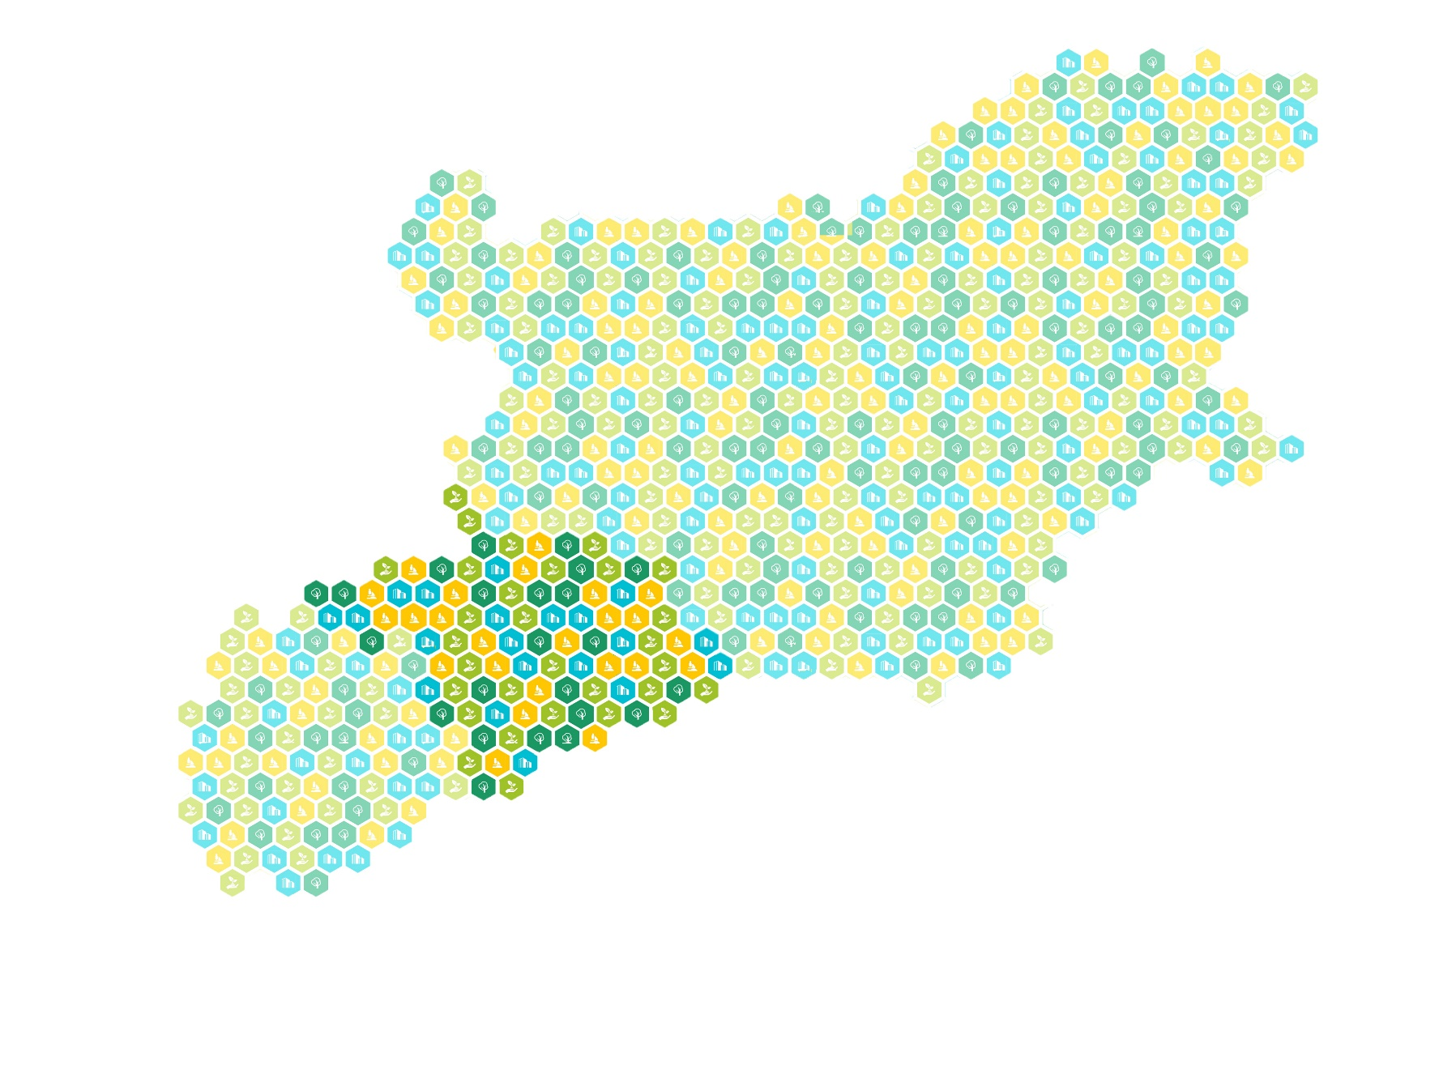
for integrated measures to be financed under
the INTERREG — IPA CBC programme 2021—2027
between
the Republic of Bulgaria and the Republic of North Macedonia

TABLE OF CONTENTS
RATIONALE 2
METHODOLOGY 2
DETERMINING THE TERRITORIAL SCOPE OF THE STRATEGY 5
STRATEGIC CONTEXT 7
EUROPEAN LEGISLATIVE AND STRATEGIC FRAMEWORK 7
STRATEGIC DOCUMENTS OF THE REPUBLIC OF BULGARIA 8
STRATEGIC DOCUMENTS OF THE REPUBLIC OF NORTH MACEDONIA* 8
ANALYSIS 10
NEEDS AND DEVELOPMENT POTENTIALS IDENTIFIED 10
Identified needs (N) 10
Development potentials (DP) 12
VISION, OBJECTIVES, MEASURES 12
TERRITORIAL COHESION AND INTENSIVE INTERVENTION ZONES 20
INVOLVEMENT OF PARTNERS/STAKEHOLDERS IN THE DRAFTING AND IMPLEMENTATION OF THE STRATEGY 23
MULTI-LEVEL GOVERNANCE AND PARTNERSHIP 23
Roles and responsibilities of partners/stakeholders 24
Sustainability of partnerships 29
METHODOLOGY FOR IMPLEMENTATION, MONITORING AND EVALUATION OF THE STRATEGY 30

RATIONALE
The purpose of this Strategy is to address the needs of the INTERREG — IPA CBC 2021—2027 Programme between the Republic of Bulgaria and the Republic of North Macedonia by proposing measures that would contribute to the sustainable economic development of the region. Those measures will be implemented within the framework of PO 5 ‘Europe closer to citizens’.
This document is developed in close coordination with local stakeholders in the CBC region.
The Strategy will contain a package of integrated measures, including the identification of functional areas, a methodology for governance, monitoring and evaluation, as well as a list of operations and potential beneficiaries to be financed under the INTERREG — IPA 2021—2027 Programme between the Republic of Bulgaria and the Republic of North Macedonia. The document will be elaborated in compliance with the legal framework while taking into due consideration the specificities of the programme area; it will focus on the cross-border dimension by identifying common challenges and development potentials.
Multi-level governance will be ensured by involving all competent levels (following a bottom-up regional approach, in close cooperation with the programme structures) in line with the principles of partnership, gender equality and non-discrimination.
The Territorial Strategy will be presented at various events and regional consultations.
According to the Proposal for a Regulation of the European Parliament and of the Council laying down provisions on the European funds for the 2021—2027 period, to strengthen the integrated territorial development approach, investments in the form of territorial tools should be based on territorial and local development strategies. Those territorial strategies should be developed and endorsed under the supervision of relevant authorities or bodies that should be responsible for the selection of operations to be supported, and/or involved in that selection.

METHODOLOGY
The methodology used in the elaboration of the territorial strategy is closely related to its main goal pursuant to the Technical Specification of the project. This implies compliance with the requirements set out in the adopted and approved Technical Specification, with past good practices, with the statutory framework, and with the guidelines in this field at European and national level. It is on this foundation that the rationale for the development and implementation of the Strategy is based.
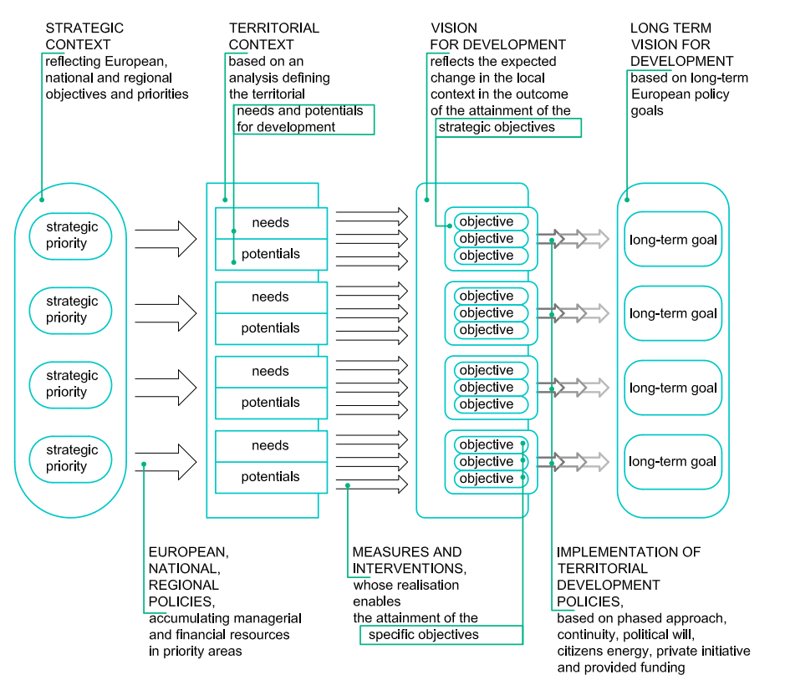
The methodology describes the process and the appropriate tools for each strategy development activity.
The launch of activities is in accordance with the Timetable and will proceed in the following logical sequence:
Step 1 Setting up a Strategy Task Force. This is a continuation of the consultations for the development of the cross-border cooperation programme. The identification of participants in the task force is based on the principle of partnership and the multi-level approach to governance, and ensures the involvement of civil society and the social partners. The task force actively participates in the coordination, review and approval of all stages of development of the Strategy.
Step 2 Defining the strategic context and methodology and determining the geographical scope of the strategy. This activity is carried out through a desk analysis of the existing strategic documents at European, national, regional and local level in accordance with the requirements of the Strategy. The geographical scope of the Strategy is determined in accordance with the European requirements and guidelines applied in the local context. As a result, an important part of it is the clear and precise argumentation of the choice of the included territory.
Step 3 Analysis of the territory. An important part of its elaboration is identifying the needs and development potentials. The thematic scope of such an analysis is oriented towards the main goal of the terms of reference and includes the following thematic areas:
1. Geographical features and environment
2. Demographic characteristics and labour market
3. Aspects of the socioeconomic development
4. Transport and engineering infrastructure
5. Cultural, historical and natural heritage
6. Tourism
The development goals and priorities, as well as the measures for their achievement at a higher level, defined in the strategic context, serve as the basis for the criteria according to which the needs and development potentials are defined on the basis of the regional reality described with the help of the collected information.
The analysis comprises a system of principles, rules and procedures. It is an amalgamation of advanced general and specific methods and tools for data processing and information analysis, for comparison and assessment. By performing a desk analysis of programmes and strategic documents, systematic classification and processing of secondary information from conducted research, content analysis, multifactor geospatial analyses, meta-analyses, comparative analyses and inventory-taking assessments, and applying traditional and specific statistical methods for data collection, the necessary source information has been amassed and summarised for putting together a comprehensive picture of the situation on the ground.
The main emphasis in doing this has been placed on avoiding an overly descriptive approach to the region and its characteristics while focusing on the common challenges on both sides of the border.
As a result of the identified needs and development potentials of the territory, the key areas of intervention are identified.
The integrated approach to addressing needs and utilising the existing potentials will be implemented through a multi-sectoral package of measures (integrated measures) for attaining the objectives of the Strategy and ensuring the active involvement of partners (stakeholders) at all stages of its development, implementation, monitoring and evaluation.
Step 4 Formulating the vision and goals of the strategy. The vision defines the desired role of the strategy as part of the organised measures for sustainable socioeconomic development of the territory.
The key (priority) areas of intervention identified provide the basis for defining its strategic goals, which in turn provide the basis for the specific objectives of the Strategy.
The strategic objective is the basis for defining the package of measures in close connection with the specific needs and potentials and the priority measures of a higher level. The integrated nature of the measures determines the need for keeping track, in the course of the process, of how adding or dropping any given measure would have an impact on the effectiveness and efficiency of the entire package.
The entire process is in line with the specifics of the terms of reference and its defining criterion is whether or not it provides opportunities for cross-border cooperation. A system of approaches (integrated, cross-border, ecosystem and location-based), principles and methods applied in the development of strategies for integrated territorial development is used. In defining its objectives, the SMART (specific, measurable, achievable, relevant and time-based) approach is applied.
Step 5 Preparing a methodology for implementation, monitoring and evaluation closely related to the results achieved so far, the technical specification of the proposal, the higher level guidelines and good practices.
Step 6 Drawing up a long list of operations. The main criterion for possible interventions is their contribution to achieving the strategic objective and the specific objectives of the programme through cross-border interventions.
Specially defined selection criteria are applied to select priority operations which are included in the short list, which is part of the cooperation programme INTERREG — IPA CBC 2021—2027 between the Republic of Bulgaria and the Republic of North Macedonia.
The developed Action Plan for the implementation of the respective 7-year strategy includes the deadlines set for the implementation of the envisaged measures for achieving the objectives of the strategy.
The successful implementation of the strategy will have a positive effect on many aspects of people’s lives. The right balance needs to be found between the cumulative effect (as many and as diverse interventions as possible) and the intensity of each individual intervention (broad and effective enough to make an impact, which also applies to the cumulative effect). It follows from this that the criteria for selecting operations should address not just each operation separately, but also the entire integrated package of operations.
The proposed methodology, as a procedural sequence of steps, correspond to the activities described in detail in the Terms of Reference.

DETERMINING THE TERRITORIAL SCOPE OF THE STRATEGY
The geographical scope of the strategy is defined in accordance with the Technical Specification for the Terms of Reference and the requirements set out in Article 23 of the Draft Common Provisions Regulation of 29 May 2018.
The choice of territorial scope proceeds from several important prerequisites:
- The analysis carried out for the needs of the INTERREG — IPA CBC 2021 —2027 Programme between the Republic of Bulgaria and the Republic of North Macedonia. That analysis has stablished the following: the existence of ‘similar economic, social and territorial challenges, needs and potentials’ provides a reason to ‘define the entire cross-border region as a functional area for which to develop a territorial development strategy’.
- The already formed Task Force has not been defined on the basis of any territorial distinction but is rather a random sample of the entire territory. At the same time, local stakeholders have stated their willingness to ‘actively participate at different stages of the elaboration and implementation of the territorial strategy’. This is a good prerequisite for satisfying one of the most important conditions for the successful development and implementation of a territorial strategy: the existence of a public consensus and commitment on the part of stakeholders to actively participate in its implementation.
- The European policy of territorial cohesion.
The entire area of implementation of the Cooperation Programme is characterised by the signs of backwardness typical for a peripheral region: low GDP, permanently negative demographic trends, large depopulating areas, shortage of qualified manpower, weak entrepreneurship, high vulnerability to natural disasters. All of that results in marked decentralisation and concentration of the population in the major cities of the relevant territory and beyond.
In addition to including common needs and potentials, the territory must create conditions for achieving the objectives defined in the strategy. The territorial nature of the strategy determines the serious impact on it of the priorities of the Territorial Agenda 2030, which have also been included in the national and regional documents relevant to the developed territory. They assign a significant role to a balanced polycentric network of cooperating cities in activating development potentials. Higher-level development centres, such as Kumanovo, Kyustendil, Shtip, Blagoevgrad, and Strumitsa, play a particularly important role in this network for the territories in both countries immediately along the border, and their inclusion in the territorial scope is of great importance. They form the backbone of the polycentric system in the relevant territory, and their relationship with the smaller towns within said polycentric model and with the rest of the territory are characterised by a high degree of interactions and interdependencies. In addition to being related to commutes to work, these large development centres are part of national and regional systems for providing health, education and other services that are ‘alive’ and still functioning. In fact, the strategy will operate on part of a system (in this case two systems) and not on a separate territory, and the proposed geographical scope reflects that fact.
Territorial Agenda 2030 also states that ‘economic prosperity in places depends on the competitiveness and creativity of their enterprises and start-ups as well as on local assets, characteristics and traditions, cultural, social and human capital and innovation capacities’.
Therefore, the definition of functional areas as ‘areas with a high degree of interactions and interdependencies, where simultaneous actions in different sectors (education, employment, transport, healthcare, support for business) are required in order to achieve future development’, included in the document ‘Political Objective 5 — Bringing Territoriality into Interreg’ of 18 June 2020, is fully applicable to the defined geographical scope of the strategy.
- On the other hand, these systems (as parts of polycentric formations) are related to the approach used in both countries for collecting and providing statistics, and taking them into account will largely ensure access to quality statistics needed to analyse the needs and development potentials of the territory, the information tools to measure the set goals and successful monitoring and evaluation of the implementation of the strategy.
We can add to this that the information from the Annual Reports on the programme shows that the main share of the implemented cross-border projects are connected with the large urban centres on both sides of the border.

From the findings so far, it can be summarised that the defined territory of the strategy:
- creates an opportunity to provide accessible and quality information for the needs of the strategy (analysis, measurability, monitoring, evaluation);
- provides an adequate territorial basis for the preparation of an integrated response to the needs and development potential of the territory, in compliance with the European strategic framework;
- is the result of a consensus of stakeholders committed to participating in the development and implementation of the strategy;
- meets the definition of a functional area set out in Interact documents.

All this gives grounds to argue that the geographical scope of the strategy defined in close coordination with the stakeholders is fully adequate to the related requirements and creates the territorial basis necessary for its successful implementation.

STRATEGIC CONTEXT

EUROPEAN LEGISLATIVE AND STRATEGIC FRAMEWORK
This document was drawn up as part of the Cross-Border Cooperation Programme INTERREG — IPA 2021 —2027 between the Republic of Bulgaria and the Republic of North Macedonia and is governed by the European legislation, at the core of which are the goals and values of the EU enshrined in the Treaty of Lisbon and the EU Charter of Fundamental Rights annexed to it; these include: peace and prosperity for the EU citizens; sustainable development based on balanced economic growth and price stability; a highly competitive market economy with full employment and social progress, and environmental protection; scientific and technological progress; economic, social and territorial cohesion and solidarity; and respect for the rich cultural and linguistic diversity of the Union.
At the same time, the document follows the guidelines laid down by a whole new generation of regulations specifically created for the long-term planning period following 2020.

Proposal for a Regulation of the European Parliament and of the Council laying down common provisions on the allocation of funds and Proposal for a Regulation of the European Parliament and of the Council on the European Regional Development Fund and on the Cohesion Fund
The rich experience accumulated during the preceding programming periods provides the EU with the knowledge and vision to formulate in the current one new policies that are closer to the people and the issues they face. The fundamental principles included in the political agreement concerning the Common Provisions Regulation on the shared management funds are include:
- channelling public investments towards a smarter, greener and more social Europe;
- partnership involving close cooperation at European, national, regional and local level as an important element at every stage of the implementation of EU funding;
- higher flexibility for transfers within cohesion policy funds and also between regions, whilst protecting the allocations of the least developed ones;
- rationalised and strategic content of the programmes, etc.
The Territorial strategy for integrated measures to be financed under the INTERREG — IPA CBC Programme 2021 —2027 between the Republic of Bulgaria and the Republic of North Macedonia is being developed on the grounds of Article 22 of the Common Provisions Regulation. It contains the elements listed under Article 23 of Regulation. Pursuant to Article 4, these funds provide financial support for five common policy objectives (PO), which are developed further in Article 2 of the Management Tool with the respective specific objectives (SO) for the European Regional Development Fund and the Cohesion Fund:

THE SIX PRIORITIES OF THE EUROPEAN COMMISSION FOR 2019—2024.
In June 2019, the European Council adopted a new agenda for the EU for the next five years: ‘A New Strategic Agenda 2019—2024’, which defines the priority areas of its work. The Commission Priorities (CP) are the result of dialogue between the leaders of the EU, ministers from the Member States, the institutions of the EU and the political groups of the European Parliament.

TERRITORIAL AGENDA 2030 — A FUTURE FOR ALL PLACES
The Territorial Agenda 2030 defines two overarching objectives: a Just Europe and a Green Europe, each with three development priorities (P).

PREPARATION FOR INTERREG POST 2020

STRATEGIC DOCUMENTS OF THE REPUBLIC OF BULGARIA

NATIONAL DEVELOPMENT PROGRAMME BULGARIA 2030
The strategic objectives laid down in the Programme are accelerated economic development, demographic upturn and reducing inequality.
Their realisation is envisioned by way of five interrelated and integrated development axes; the current Strategy includes priorities in the areas of education and skills; circular and low-carbon economy; green and sustainable Bulgaria; digital connectivity; local development; social inclusion.

NATIONAL CONCEPT FOR SPATIAL DEVELOPMENT FOR THE PERIOD 2013–2025 (2019 UPDATE)
The National Concept, with its three strategic goals of territorial, economic and social cohesion, is supported by specific objectives and priorities, among which:
- Integration into the European space
- Polycentric territorial development
- Regional competitiveness promoting growth

INTEGRATED TERRITORIAL DEVELOPMENT STRATEGY FOR THE SOUTH- EAST REGION
The strategic priorities are: promoting an innovative and smart economic transition; retaining and developing the human capital; and better connectivity. Specific objective 3.5. ‘Strengthening the prospects of cross-border cooperation’ has a direct impact on the present document.

STRATEGIC DOCUMENTS OF THE REPUBLIC OF NORTH MACEDONIA*
The documents referred to herein are elaborated thoroughly and in detail; they present a comprehensive picture of the current situation and indicate clearly and in no uncertain terms the future needs and development priorities.

STRATEGY FOR BALANCED REGIONAL DEVELOPMENT OF THE REPUBLIC OF NORTH MACEDONIA 2021—2031
Significantly strengthened regional development policy, more evenly developed, economically and environmentally sustainable and competitive planning regions through consistently applied smart specialization and stronger stimulation of private investments in synergy with public ones.

DEVELOPMENT PROGRAMME FOR THE NORTH-EAST PLANNING REGION 2021—2026
Achieving sustainable economic development through large investments, a better distribution environment and strengthening competitiveness, attracting foreign and stimulating domestic investment, including the transfer of experience, knowledge and best practices. Gradually adapting knowledge, skills and competencies of the workforce according to the needs of the market and investors.
Development of entrepreneurship, small and medium enterprises, business incubators, accelerators and entrepreneurial infrastructure.
Development of rural and alternative tourism.

DEVELOPMENT PROGRAMME FOR THE EAST PLANNING REGION 2021—2026
Development of a competitive and innovative regional economy, promotion of domestic investments and attraction of foreign ones, improvement of the competitiveness and innovation potential of the existing enterprises, promotion of entrepreneurship and self-employment.
Achieving greater productivity and competitiveness of the workforce by improving its skills and competencies and creating conditions for quality education. Including: establishment of regional centers for vocational education and training, promotion of elder education, improvement of digital skills, support for applied research activities in higher education.
Integrated waste management system and promotion of the circular economy, by raising awareness and training on proper waste management, supporting pilot projects for circular and green economy.
Tackling the effects of climate change, sustainable crop residue management and promoting energy efficiency.
Capacity building and support for entrepreneurship by young people and vulnerable groups in rural areas, preservation and development of traditions, culture and crafts in rural areas, development and promotion of rural tourism.
Improving the quality of life in villages, areas with specific development needs and areas in a phase of strong depopulation, conducting social and cultural activities in villages

DEVELOPMENT PROGRAMME FOR THE SOUTH-EAST PLANNING REGION 2021—2026
Development of entrepreneurship, promotion of competitiveness and innovation of enterprises and creation of a favorable investment climate. Increasing the skills and entrepreneurial capacity in the region with a special focus on women and youth; creating a network of organizations to support start-ups and promote entrepreneurship; creating a business incubator for companies with a special focus on companies founded by women and young entrepreneurs; creating a network of mentors in support of existing SMEs, promoting and improving the social responsibility of the business community
Development and popularization of the region as an attractive tourist destination modernization of mountain lodges and private accommodation in the region; promotion of the tourist offer of the region; promotion and support of various types of tourism (lake, spa, rural, cultural and pilgrimage, active, health, event, conference, hunting, wine); education in protection of the region's natural and cultural heritage; improving the capacity of human resources in the tourism sector.
Promoting social inclusion, competitive and quality education and health care of the population in the region, creating a workforce according to the needs of the labor market;
Promotion and branding of agricultural products and processed products from the region; diversification of economic activities in rural areas;
Promoting the circular and green economy: creating a regional system for integrated waste management
Developing entrepreneurship and industry, promoting competitiveness and innovation of enterprises, and creating a conducive investment climate

ANALYSIS

NEEDS AND DEVELOPMENT POTENTIALS IDENTIFIED
As a result of the analysis of the current situation, the meta-analyses of strategic documents at European, national and regional level, and taking into account the specifics of the territory under consideration, we have attempted to outline the entire range and diversity of needs and development potentials.
Future structural interventions in key thematic areas defined by their common and/or mutually compatible characteristics are a tool for using cross-border cooperation in promoting the socioeconomic cohesion and development of the region.
Applying a balanced and integrated approach, purpose-oriented to address the specific territorial needs, is of key importance for attaining synergic and sustainable end results for ironing out the imbalances in the development of the territory.
The area of cross-border cooperation, seen in and of itself, represents an entire universe of pent-up issues in different spheres generating a negative sum total, thus leading to a deepening of the already acute problems and having an overall negative impact in all areas.
In order to achieve an all-round positive cumulative effect, it is advisable to ensure the implementation of the necessary minimum of targeted territorial interventions in different spheres.
Their integrated result will be able, through its long-term effect, to turn around the current trends by putting the territory on track towards long-term socioeconomic stability and sustainable development.

Identified needs (N)
- elaborating a common vision of the CBC region with a long-term perspective by using tools and practices to ensure a broad public participation while factoring in the specific challenges characteristic of third country border areas;
- targeted interventions for ironing out significant disparities between population centres at different hierarchical levels in the territorial structure with a view to addressing the issue of depopulation by implementing packages of integrated measures to retain the population;
- a balanced development of the business environment in the CBC region by means of targeted support both for the less developed regions and for the launch of high-tech, high-added-value industries;
- increasing the attractiveness of the CBC region for foreign direct investments;
- promoting entrepreneurship by improving the business environment utilising available local resources;
- SMEs, with an emphasis on family businesses, singled out as a leading factor for sustainable socioeconomic development by support for/raising the competence of SMEs for participation in European and national funding programmes;
- a need to increase the competitiveness of SMEs by raising their qualifications and acquiring crucial skills in leadership, management, marketing, digital literacy and other competences;
- raising the resource and energy efficiency of SMEs and support for the introduction of models of the circular economy;
- Continuous technological renewal of the SMEs involving new knowledge and skills, machinery, software products and the introduction of digital technology;
- improving the corporate culture of cooperation among SNEs, including their joint participation in projects and programmes seeking external financing and addressing common challenges in a highly competitive environment;
- support for entrepreneurs and the hired workforce for raising their qualifications involving market research, upgrading existing and introducing new industries and marketing of the products of SMEs in the domestic and foreign markets;
- measures to address the issue of the shortage of qualified personnel and raising the qualification of executive and senior management staff by continuing education, refresher and re-training courses in accordance with the needs of the business sector;
- territorially focused measures for addressing unemployment in the problem areas of the CBC region, for encouraging economically inactive persons to seek employment, and for incentivising the business sector for job creation;
- making the fullest use of investment and development opportunities created by the fact of Corridor No 8 running across the CBC region, in the interest of local SMEs;
- securing investments in the modernisation of existing and/or construction of new sites and facilities of the engineering and transport infrastructure in accordance with local needs: road and rail junctions, water supply and sewerage, electric power, renewables, safety and security facilities, telecommunications, in order to improve the possibility of all-season tourism;
- improving territorial connectivity by opening a new border crossing point, Klepalo, connecting the municipalities of Strumyani and Berovo;
- developing a system of alternative mobility, including a grid of bicycle lanes, ‘dirt’ forest and country roads, a network of e-car charging stations, helipads, etc.;
- joint action to reduce national and cross-border pollution of the air, soil, and water;
- joint measures to reduce carbon emissions, including seasonal pollution, and for adapting to climate change;
- preventive measures to avert the risk of fires, floods, earthquakes, the triggering of landslides and rock avalanches;
- coordinated joint action in the event of natural or man-made disasters;
- coordinated action for collection, processing and recycling of solid waste;
- improving the public information systems of cultural and historical sites, natural landmarks and regarding the conservation status and possible actions for conserving elements of the environment with a view to restoring ecological balance;
- targeted development and maintenance of the infrastructure of cultural and historical sites and natural landmarks;
- joint action in the area of cultural heritage exchange and improving the visibility of cultural and historical institutions and events;
- evening out the markedly seasonal nature of tourist services in the CBC region;
- targeted measures for promoting ecological tourism;
- financial support for cultural activities and cultural heritage exchange;
- integration of the cultural heritage and natural landmarks into the offering and development of a tourism product;
- joint measures to mitigate the vulnerability of services in the tourism sector to pandemic and epidemic situations;
- increasing the security and safety of tourism sites and destinations.

Development potentials (DP)
- a steady trend of sustainable economic growth, adequate resources for economic diversification and increased economic activity of the SMEs;
- relatively good territorial saturation with educational infrastructure, existence of centres of higher education and secure access for the population to all levels of education;
- relatively good territorial saturation with social and primary health services infrastructure;
- existence of a rich cultural and historical heritage featuring a wide diversity of cultural and historical monuments and sites, similar crafts, traditions and customs;
- a diverse natural environment with its unique flora and fauna and natural landmarks;
- the fact that the CBC region is crossed by the Sofia—Ohrid cultural corridor and its proximity to Via Diagonalis connecting Southern Europe with Asia and the sites connected by these;
- one of the core corridors of the TEN-T Network (Orient/East-Med) passes across the CBC region, including with its branches to third countries;
- existence of three fully operational border crossing points;
- relative proximity of the CBC region to the international airports at Sofia and Skopje;
- an opportunity for creating a regional tourism product based on natural assets, cultural heritage, mineral springs and a relatively good tourism infrastructure;
- an opportunity for increasing competitiveness by promoting the development of sustainable, all-season, high-quality tourism;
- an opportunity for promoting local crafts and services by adapting them to the current market situation.

VISION, OBJECTIVES, MEASURES
VISION: The CBC region of the Republic of Bulgaria and Republic of North Macedonia: a place for consolidation and stability of the cultural and historical heritage through joint efforts for mutually beneficial cooperation, socioeconomic cohesion and balanced sustainable development.
This Vision will be achieved by the formulation and subsequent implementation of activities that have a maximum impact on the effectiveness of the cohesion policy. The territorial tools used for the attainment of Policy Objective 5 (PO5) may combine within themselves activities funded under any other Policy Objectives, making it possible to apply a truly multi-sectoral integrated approach tailored to the local requirements.
The synergy in applying different tools will allow to achieve an all-round cumulative effect. To this end, the implementation of the necessary minimum of territorially focused interventions in the various areas will be ensured. The entire process will be based on multi-level governance by involving all competent levels (following a regional bottom-up approach in close interaction with the programme structures) in line with the partnership principle.

The integrated approach to meeting/addressing the needs and potentials of the territory in the developed strategy is manifested in three main aspects:
- a territory defined on the basis of achievement of sustainable results with respect to common needs and development potentials;
- participation of a wide range of partners in the entire process of drafting, discussion, adoption and implementation of the strategy;
- a package of interconnected and complementary (integrated) measures based on close coordination of different public policies according to local specifics, meeting local needs and development potentials and bringing common benefits to partners and the region.
The priority areas of intervention identified through the analysis of needs and potentials are as follows:
- socioeconomic development and cohesion;
- infrastructure and border aspects;
- environmental protection and biodiversity conservation;
- cultural and historical heritage and tourism.

The ultimate outcome of the implementation of the Strategy will be strengthening of the territorial cohesion through balanced sustainable development in the cross-border region between the Republic of Bulgaria and the Republic of North Macedonia.
Following the logic of the strategic context and the findings of the analysis, the principles of structuring a ‘goals tree’ are applied. A three-tier hierarchical structure is created comprised of: strategic objective (SO), specific objectives (SpO) and measures for their attainment (М).

SO: Social development and cohesion through sustainable economic growth based on a ‘knowledge economy’ and aimed at ironing out the significant differences between population centres at different hierarchical levels in the CBC region:

SpO 1.1. Increase the competitiveness of the local economy and improve the business environment:
М 1.1.1. Increasing the productive capacity of the SMEs to become greener, more digital and more competitive (technological modernization); N4, N8, N9
М 1.1.2. Improving the knowledge capacity of the SMEs to operate in a greener, more digital and more competitive environment (acquiring new knowledge and skills, incl. access to external finances); N6, N7, N10, N12
М 1.1.3. Building effective product development process (it encompasses all steps needed to take a product from concept to market availability) and reaching new markets (marketing, entrepreneurship, internationalization); N5, N11

SpO 1.2. The cultural and historical heritage of the Republic of Bulgaria and the Republic of North Macedonia: a prerequisite for the development of an attractive, all-season tourism product by means of smart solutions that ensure universal access and participation
М 1.2.1. Improving the mobility and connectivity of the transport and engineering infrastructure by a system of alternative mobility, including a grid of bicycle lanes, ‘dirt’ forest and country roads, helipads, etc.; N15, N17
М 1.2.2. Development and marketing of integrated regional tourism products suitable for various activities through the inclusion of the cultural and historical heritage and natural assets; joint efforts for diversification of the forms of tourism services and the realisation of all-season tourism in the CBC region;
N27
М 1.2.3. Development of integrated targeted financial packages for supporting business activity and the creation of new SMEs in tourism with a focus on family businesses and the offering of local tourism products: wine and gourmet tourism, rural eco-tourism, cycling tourism, hunting and fishing, off-road tourism, etc.; N2, N6
М 1.2.4. Creating a joint network of locations for the realisation of concepts like ‘green school’, ‘in the country’, ‘visiting with...’, ‘made by...’, etc.; N30
М 1.2.5. Elaborating and applying joint measures for reducing the vulnerability of services in the tourism sector to the effects of pandemic and epidemic situations; promoting the development of health and recreational tourism: products and services related to physical exercise, outdoor sports, strengthening the immune system and improving the health status through spa procedures, climate therapy, mud therapy; combining short breaks of different kinds with individual travel; N31

This specific objective derives both from the needs and potentials formulated as a result of the SWOT analysis and from the basic premises of the European Framework for Action on Cultural Heritage which rests on five ‘pillars’:
Pillar 1: Cultural heritage for an inclusive Europe: participation and access for all;
Pillar 2: Cultural heritage for a sustainable Europe: smart solutions for a cohesive and sustainable future;
Pillar 3: Cultural heritage for a resilient Europe: safeguarding endangered heritage;
Pillar 4: Cultural heritage for an innovative Europe: mobilising knowledge and research;
Pillar 5: Cultural heritage for stronger global partnerships: reinforcing international cooperation.

Horisontal policy
Each supported intervention needs to include component that contribute to the protection of the environment and biodiversity or provides green solutions. Thus, the green policy becomes integral part of the integrated territorial development

Part of the thus defined needs remain uncovered by measures envisaged the present Strategy as they are linked to the implementation of policies for addressing cross-border and transnational issues of a higher hierarchical order or with other strategies or sectoral policies.
The integrated measures for a balanced territorial development formulated herein cannot be self-seeking or fragmented. Their viability and effectiveness are related to meeting the requirements for sustainability of the biological environment.

- Raising awareness of the state of the environment and the impact of climate change on life on the planet, human health and biodiversity would contribute to mitigating the adverse effects of climate change and predictable natural disasters of a cross-border nature. N23
- The territorially-oriented measures formulated herein above, aimed at the attainment of the two specific objectives in the context of improving labour mobility and ironing out the significant differences between population centres, must be supported with environment-friendly initiatives: modernisation of the transport fleet, non-polluting vehicles, public transport, shared travel, etc.; N17
- Reducing local and cross-border pollution of the air and water currents and basins; encouraging the use of alternative heaters and fuels (other than solid fuel); increasing the share of collected, processed and recycled household waste and the share of the population using waste treatment services are also of considerable importance for achieving sustainable growth; N18, N19, N22

- The Vision of this Strategy has a long time horizon, is of the highest hierarchical level and derives from the common policy of cohesion, integration and sustainable development of the border areas between the Republic of Bulgaria and the Republic of North Macedonia;
- The Strategic Objective is the highest hierarchical level of goal decomposition. The strategic objective is formulated as a result of targeted thematic analysis and the priority areas of intervention derived through it;
- The Specific Objectives form the next hierarchical level. They are formulated on the basis of the needs and potentials identified in the analysis. The attainment of the specific objectives in their totality is a necessary and sufficient precondition for the realisation of the relevant strategic objective. They are bound to performance indicators showing the measurability/ratio between baseline and end value.
- The measures (SMART) are specified synergic actions whose cumulative totality is the means to attaining the specific objectives. They lie at the foundation of the entire pyramid of organisational, temporal and spatial elements that are being materialised through projects and interventions, ultimately ensuring the attainment of the strategic objective.

SMART:
- Specific: related to needs and development potentials of the territory that are precisely defined in the analysis.
- Measurable: they can be measured by determining the ratio between the baseline value of the indicator(s), the value of the indicator(s) expected without intervention, and the achieved value of an adequate indicator or by comparing between individual indicators.
- Achievable: the funding provided and the ongoing process of realisation of the specific objective by developing the current strategy are proof of its attainability.
- Relevant: they help satisfy needs and development potentials of the territory that are specifically defined in the analysis, thus contributing to the cumulative effect of measures integrated in the overall package while also being related to the attainment of other specific objectives at European, national and regional level.
- Time-based: must be attained within the time period for the implementation of the strategy.

STRATEGIC CONTEXT

MULTIFACTOR ANALYSIS
SWOT analysis
Geographical characteristics and environment
SWOT analysis
Transport and engineering infrastructure

SWOT analysis
Demographic characteristics and labour market

SWOT analysis
Cultural-historical and natural heritage and tourism

SWOT analysis
Aspects of socio-economic development

Package of integrated measures
Package of integrated measures

Increase the competitiveness of the local economy and improve the business environment
The cultural and historical heritage of the Republic of Bulgaria and the Republic of North Macedonia: a prerequisite for the development of an attractive, all-season tourism product by means of smart solutions that ensure universal access and participation
Strategic Objective: Social development and cohesion through sustainable economic growth based on a ‘knowledge economy’ and aimed at ironing out the significant differences between population centres at different hierarchical levels in the CBC region
SpO 1.2.
SpO 1.1.
LIST OF OPERATIONS TO BE SUPPORTED
LONG LIST OF OPERATIONS
NEEDS/34
VISION: The territory of the Republic of Bulgaria — Republic of North Macedonia CBC region: a place for consolidation and stability of the cultural and historical heritage through joint efforts for mutually beneficial cooperation, socioeconomic cohesion and sustainable development
POTENTIALS/12

The Strategic Objective, the Specific Objectives and the Measures formulated in the Strategy and their horizontal projection on the CBC region are supported and rationalised in strategic documents and studies that are of fundamental significance for the European development policies and apply to the model of interaction illustrated herein:
1. Undertaking steps to ensure that the citizens of the EU have the necessary skills to succeed in the labour market as a factor of crucial importance for increasing economic growth and employment in the EU.
European Council, Council of the European Union
https://www.consilium.europa.eu/bg/policies/education-economic-growth/
2. An economy that works for people
Individuals and business entities in the EU can only prosper if the economy works for them. The EU’s unique social market economy allows for economic growth and for reduction of poverty and inequality.
Of considerable importance to that end is to strengthen small and medium-sized enterprises, which form the backbone of the European economy.
European Commission, Priorities 2019—2024
https://ec.europa.eu/info/strategy/priorities-2019-2024/economy-works-people_bg
3. Climate change and the deterioration of the environment are a threat to the very existence of Europe and the world.
European Commission, Priorities 2019—2024
https://ec.europa.eu/info/strategy/priorities-2019-2024/european-green-deal_bg
Biological diversity is a life supporting factor. It is of paramount importance for people because of reasons related to both environmental protection and the climate. Biological diversity is of vital importance for protecting human health and supporting the economy.
European Council, Council of the European Union
https://www.consilium.europa.eu/bg/policies/biodiversity/
4. Climate change and the deterioration of the environment are a threat to the very existence of Europe and the world. To address those challenges, Europe needs a new growth strategy aimed at turning the European Union into a modern, resource efficient and competitive economy.
European Commission, Priorities 2019—2024
https://ec.europa.eu/info/strategy/priorities-2019-2024/european-green-deal_bg
5. The longer the respondents remain part of the education system, the more likely it is for them to be aware of Natura 2000 (38 % vs. 17 %). The share of people who have heard of Natura 2000 and know what is about varies between 18 % of those who have left the education system at 20 or younger and a mere 3 % of those who have dropped out before the age of 15.
A survey of public attitudes towards biological diversity.
https://ec.europa.eu/commfrontoffice/publicopinion/index.cfm/Survey/getSurveyDetail/instruments/SPECIAL/surveyKy/2194
6. Climate change and the deterioration of the environment are a threat to the very existence of Europe and the world.
European Commission, Priorities 2019—2024
https://ec.europa.eu/info/strategy/priorities-2019-2024/european-green-deal_bg
Biological diversity is a life supporting factor. It is of paramount importance for people because of reasons related to both environmental protection and the climate. Biological diversity is of vital importance for protecting human health and supporting the economy.
European Council, Council of the European Union
https://www.consilium.europa.eu/bg/policies/biodiversity/
7. The overarching goal of all public policies should be to improve the wellbeing and quality of life of the population. They go beyond economic results, living standards and purely material aspects by also including access to quality health services, freedom of movement and a healthy, sustainable and high-quality urban environment. They also have a territorial dimension varying from differences between neighbourhoods in terms of social exclusion and urban poverty to differences between regions and countries.
Territorial Agenda 2030
https://www.territorialagenda.eu/home.html
8. The wellbeing of rural areas depends on their capacity to tap human potential and harness local resources; at the same time, factors related to location come into play, making life and the economic conditions there more attractive to people and businesses.
In areas far removed from the major cities, the medium-sized cities and smaller towns are those that play a crucial role in providing access to services by ensuring that these areas remain attractive places to live in.
European Economic and Social Committee
https://www.eesc.europa.eu/en/our-work/opinions-information-reports/opinions/towards-more-balanced-territorial-development
9. Economic prosperity at local level depends on the competitiveness and creativity of the relevant businesses and start-ups as well as on local assets, characteristics and traditions, cultural, social and human capital and capacity for innovation.
Territorial Agenda 2030
https://www.territorialagenda.eu/home.html
10. The processes of industrial symbiosis in the regional value chains are also important. The transition of the European economies towards locally based circular and climate-neutral economy has a territorial dimension and may strengthen the functionality of the region.
Territorial Agenda 2030
https://www.territorialagenda.eu/home.html
11. A well-balanced territorial development means a more even and sustainable utilisation of natural resources, which brings economic benefits in the form of less overload and lower costs.
European Economic and Social Committee
https://www.eesc.europa.eu/en/our-work/opinions-information-reports/opinions/towards-more-balanced-territorial-development
12. The natural and the cultural heritage are local assets for regional development offering unique opportunities for development and a quality living environment. The sustainable and efficient use of resources must benefit the local communities while promoting local business opportunities.
Territorial Agenda 2030, https://www.territorialagenda.eu/home.html

TERRITORIAL COHESION AND INTENSIVE INTERVENTION ZONES
The goal of meeting the identified needs by strengthening the polycentric model of development and thus reducing spatial imbalances lies at the heart of the territorial cohesion of the measures integrated in a multi-sectoral package. The priorities of the Territorial Agenda 2030, adapted to the context in the national and regional strategic documents, determine the crucial role of the polycentric networks of cities as drivers of economic and social development. The importance of small and medium-sized cities for ‘regional economic development, social well-being and adequate access to services’ at local level is emphasised.
The core of the polycentric network in the developed territory consists of five large urban centres (Kumanovo, Kyustendil, Stip, Blagoevgrad, Strumica) and the urban axes connecting them. A network of smaller centres with municipal and supra-municipal functions is developed around this core. The word center in this case does not carry the charge of the familiar administrative and social concept. The main role of the centers will be, using the existing material and moral accumulations in them, to contribute to the faster and better implementation of the strategy measures, which are directed outside them, to the smaller settlements in the whole CBC area.
While the territory within the geographical scope of the Strategy is characterised by common needs and development potentials, a tailor-made approach to interventions more thoroughly linked to the specifics of the local context makes it possible to identify Intensive Intervention Zones within it. Within their scope, the more intensive implementation of some of the integrated measures in the overall package is expected to produce a better result and bring more tangible benefits to the entire territory. In this way, the measures envisaged and implemented in the entire functional area for which the Strategy is being developed increase not only their effectiveness, but also the effectiveness of the package of integrated measures as a whole.
Each of them also contains two higher-level development centres (larger cities) and is thus connected to the core of the polycentric network. This connection has not only a spatial dimension but also a functional dimension — in larger and more developed cities it is easier to achieve results in the field of new technologies (green, circular, digital) and there it is most likely to take the first steps and give impetus to the development of the entire territory.
The zones overlap or intersect with one another. The different cities and the territories around them fall into several different zones at the same time, which determines their profile in terms of the intensity of the different interventions.
The emergence of functional zones has its logical rationale and is the natural result of the analysis carried out. The similar characteristics of neighbouring territories on both sides of the border, with similar resources, advantages and disadvantages concentrated in them, naturally indicate where the Strategy’s areas of intervention need to be delineated.
Zone of the European Green Belt – a zone determined by an increased contribution of the natural heritage to a balanced and sustainable socioeconomic development. Implementation of preventative joint initiatives for the creation of green belts and protective clearings; control of the elements of the ecosystem with a view to protection and conservation of the environment, the biological diversity and the green infrastructure while reducing all forms of pollution. The leading centres here are Kyustendil and Strumica which will serve not only as a link with the polycentric network but also as two distinct nuclei of application and dissemination of interventions and innovations pursuing ecological (‘green’) aims within the framework of the measures of the Strategy. It is through them than an impetus will be given to the development of the entire area in the sphere of the green infrastructure and the circular economy.
Zone of active transport communication. This zone is characterised by functional communication owing to the existing transport links. Interventions in it will be focused on upgrading the existing and construction of new sites and facilities of the transport infrastructure, on ensuring connectivity and ironing out the existing differences between population centres at different hierarchical levels in the territorial structure. The cities of Kumanovo and Kyustendil are situated along the main communication route running across the area of implementation of the Strategy and connecting the capital cities of Sofia and Skopje. Thus they are positioned to assume the role of logistical economic centres for improving the human habitation environment within the zone and promoting cohesion with smaller population centres, which will receive a boost in their development through improved cross-border functional links not just in the sphere of the economy, but also of education, the social services, tourism, employment, etc.
The opening of a new border crossing point would lead to the expansion of that zone and to accelerated intensive development of the cross-border area. The envisioned development of an alternative mobility system is a step towards strengthening the ‘green’ effect of the Strategy and achieving a balanced and sustainable development of the territory.
Cities as Centres of Knowledge – Blagoevgrad and Stip are the academic centres in the territory under review. Education and science are fundamental to the development of knowledge. Without underestimating the capabilities of other areas, the strategy will try to use the potential of the established educational centers. The message of the strategic goal is harmonized with this. Again, the word "Center" is used in the sense of "center of knowledge" - a source of dissemination of measures and future operations to the entire CBC area. As stated in the strategic objective "Social development and cohesion through sustainable economic growth based on a ‘knowledge economy’ and aimed at ironing out the significant differences between population centres at different hierarchical levels in the CBC region", future interventions will be sought mainly outside the big cities, looking for the cohesion so desired. The higher education institutions in both cities, as sources of knowledge, may have an extremely positive impact on the implementation of measures under both specific objectives for the entire zone. Cross-border cooperation at academic level may help raise the awareness, knowledge and educational status of the local population, which will thus receive support for higher-quality employment, greater opportunities for professional advancement and competitiveness in the labour market. At the same time, appropriate public awareness campaigns can be organised to raise the ‘locals’’ motivation for protecting and safeguarding the natural, cultural and historical assets of the area for the benefit of promoting all-season tourism. The interaction between universities on both sides of the border in the sphere of protection, exploration, restoration and preservation of historical artefacts in the territory and the conservation of its natural assets constitutes a new scope for its development offering new opportunities and prospects. Academic collaboration is an important factor at times when ‘smart’ and innovative solutions are being sought, and may have a very favourable effect on the development of the entire ‘zone of intervention’.
Zone of intervention — the entire territory covered by the Strategy comprised of urban areas, industrial zones and degraded lands, areas with tourism potential (historical, cultural, natural, etc.), which provide a wide range of opportunities and weaknesses
Specific Objective 1: Increase the competitiveness of the local economy and improve the business environment:
Promoting social entrepreneurship, the growth of the services sector and providing enabling conditions for job creation and self-employment are among the core measures for attaining that objective.
Providing opportunities for cooperation, including cross-border, between educational and vocational training institutions and the business sector supports the professional development of young people. The implementation of dual education, the development of innovative approaches to vocational training, distance learning and specialised education are conducive to the development of flexible systems of self- and corporate employment. Enabling conditions are being created for developing work skills and improving labour mobility in the CBC region.
The attainment of this specific objective will contribute to the successful realisation of the strategic objectives whereby sustainable socioeconomic development is based on a ‘knowledge economy’.
Specific Objective 2. The cultural and historical heritage of the Republic of Bulgaria and the Republic of North Macedonia: a prerequisite for the development of an attractive, all-season tourism product by means of smart solutions that ensure universal access and participation
The tourism sphere is possibly one of the most comprehensive strategic areas of cross-border cooperation, and the cultural, historical and natural assets, the numerous spiritual sites and places of worship on both sides of the border, are a starting point for cohesion and shared development.
Good digitisation is important for keeping people aware of the processes, creating a competitive business environment; it is a prerequisite for ‘closing the cycle’ and finding a marketplace for small and medium (family) businesses, for the development of a services industry, crafts, ‘clean’ industries and strengthening the circular economy. Cultural and spiritual needs, science and education similarly find a new field for manifestation in the digital space. Digital museums, galleries, schools and science platforms are gaining strength, becoming an increasingly common part of our daily lives. This is especially true in the conditions of a pandemic. Change is already here: ‘the new normal’ is in moving part of our lives into the digital reality of a new type of connectivity, through virtual communication at many levels.
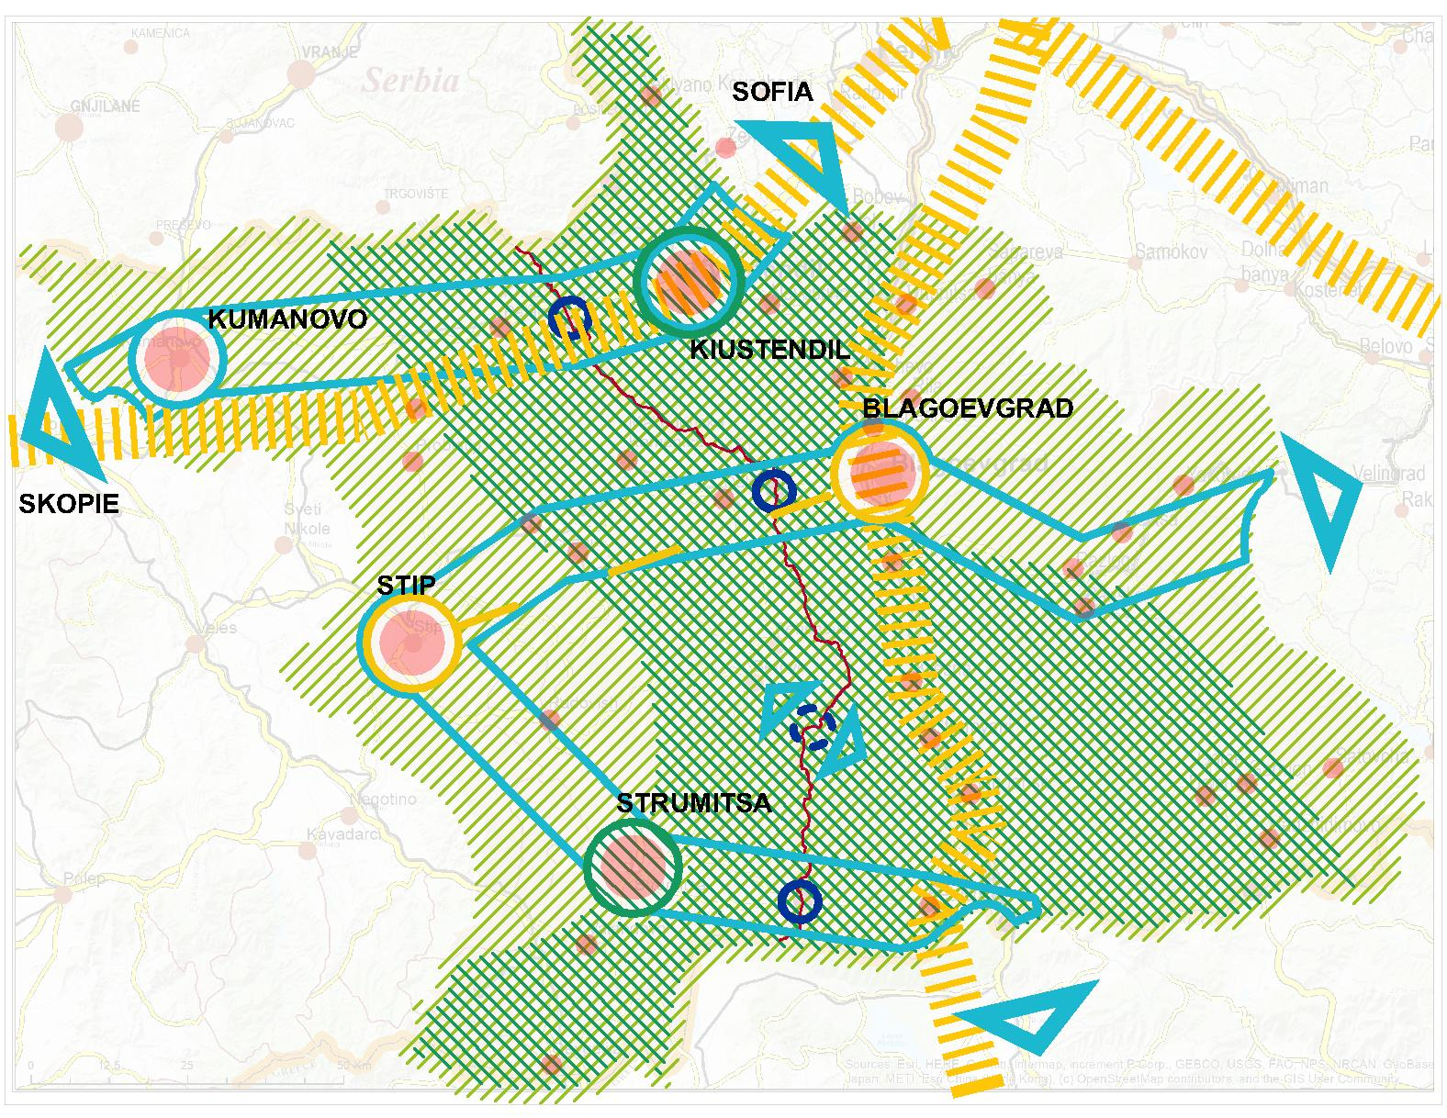
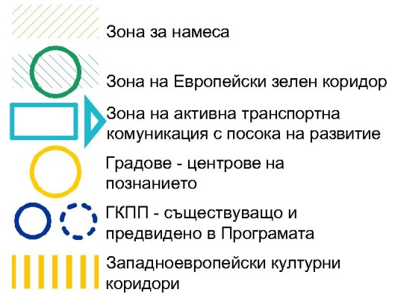
Zone of intervention
Zone of the European Green Corridor
Zone of active transport communication with the direction of its development
Cities as centres of knowledge
Border crossing points (existing and envisioned in the Programme)
European cultural corridors

The measures under SpO 1 and SpO 2 of the Strategy are territorially defined and cover the entire CBC region. The first three zones are linear or made up of individual points; they provide the backbone stimulating a balanced and sustainable social and economic development. The entire territory of CBC in its geographical dimension represents a single ‘Functional Zone’: a zone of cross-border cooperation.

INVOLVEMENT OF PARTNERS/STAKEHOLDERS IN THE DRAFTING AND IMPLEMENTATION OF THE STRATEGY

MULTI-LEVEL GOVERNANCE AND PARTNERSHIP
Commission Delegated Regulation (EU) No 240/2014 of 7 January 2014 on the European code of conduct on partnership in the framework of the European Structural and Investment Funds (ESIF) published by the European Commission aims to assist and facilitate countries in organising partnerships with regard to partnership agreements and programmes implemented with the support of the ESIFs. Partnership is a long-standing principle in the work of the ESIF and implies close cooperation between public authorities, economic and social partners, and civil society organisations at national, regional and local level throughout the programming cycle consisting of preparation, implementation, monitoring and evaluation. Partners are involved in the preparation and implementation of partnership agreements and programmes. To this end, the basic principles and good practices for conducting a timely, in-depth and transparent process of consultation with partners on the analysis of the challenges and needs to be addressed, of selection of objectives and priorities for overcoming them, as well as with regard to the coordination structures and multi-level governance arrangements needed for effective policy implementation have been established.
The consultation of the partners/stakeholders referred to in Article 5 of the Regulation shall ensure the transparent and effective involvement of relevant partners, shall consult them on the process and timetable of the preparation of the Partnership Agreement and programmes and shall keep them fully informed of the content of said documents and of any changes thereof. As regards the consultation, the following shall be taken into account: the need for timely disclosure of and easy access to relevant information; the need for sufficient time for partners to analyse and comment on key preparatory documents; the need for available channels through which partners may ask questions, may provide contributions and will be informed of the way in which their proposals have been taken into consideration; the need for the dissemination of the outcome of the consultation. Where formal agreements have been established between the different tiers of government below national level, the Member State shall take account of these multi-level governance agreements in accordance with its institutional and legal framework.
According to Articles 7 and 9 of the same Regulation, the information regarding the involvement of partners/stakeholders in the Partnership Agreement and in the preparation of the programmes shall include: the list of partners; the actions taken to ensure the active participation of the partners, including actions taken in terms of accessibility; the role of the partners; the results of the consultation with partners and a description of its added value.

Roles and responsibilities of partners/stakeholders
The role of the partners is emphasised by the participation of representatives of the civil society, the academic community, local authorities, socioeconomic entities and associations, etc., as members of the task force which prepare the strategic documents. By participating at an early stage they have the opportunity to influence the preparation of documents.
The Integrated Territorial Strategy for the needs of the INTERREG — IPA CBC 2021—2027 Programme between the Republic of Bulgaria and the Republic of North Macedonia is developed jointly with the Task Force (TF) established on the basis of the above-mentioned considerations, as well as in compliance with Commission Delegated Regulation (EU) No 240/2014 of 7 January 2014. The Task Force, which is widely involved at all stages of the development, coordination, approval and implementation of the strategy, ensures the continuation of the public consultation process for the preparation of the INTERREG — IPA CBC 2021—2027 Programme between the Republic of Bulgaria and the Republic of North Macedonia.
TF members are nominated according to the relevant institutional and legal framework and in compliance with the partnership principle. The Task Force is composed of a balanced number of representatives from both partner countries, including representatives of public authorities (national, regional and local), economic and social partners, relevant bodies representing civil society, including environmental partners, non-governmental organisations and bodies responsible for promoting social inclusion, gender equality and non-discrimination.
The process of drafting the Integrated Territorial Strategy begins with setting up the Task Force composed of the relevant regional and local authorities and bodies, as well as of other local stakeholders responsible for the preparation of the strategy. The Consultant, together with the Task Force, identifies the geographical coverage of the document and develops the analysis of the needs and development potentials of the covered territory, on the basis of which the key areas of integrated strategic intervention should be addressed. Also together, the Consultant and the Task Force prepare the methodology of the Strategy, determine the involvement of partners/stakeholders in its preparation and implementation taking into account the principle of multi-level governance, and develop the methodology for its implementation, monitoring and evaluation.
The TF discusses and approves the list of operations to be supported, prepared on the basis of mapping of possible interventions for integrated economic and social development, protection of cultural and natural heritage, sustainable tourism, etc., as well as the target groups and potential beneficiaries identified. The operations on the list are grouped, prioritised and time-bound on the basis of transparent and clear methodology and selection criteria. The exact budget to support operations is agreed with the TF.
The Task Force participates actively in the coordination, review and approval of all stages of development of the Integrated Territorial Strategy, ensuring wide publicity by presenting the Strategy at various events (relevant meetings of the Task Force, regional consultations, etc.). The Final Report must reflect the comments and observations received during the consultation and approval procedures, as well as the results of the Strategic Environmental Assessment (SEA).
The integrated strategy is the tool that shapes and leads to the implementation of Priority Objective 5, i.e. operationalises the support for integrated territorial development. The Strategy identifies needs and proposes interventions for addressing them in accordance with the SMART approach. In close cooperation with the Task Force, a list of operations to be supported is prepared based on the localised possible interventions for integrated development of the region, and target groups and potential beneficiaries are identified. The operations on the list are grouped, prioritised and time-bound on the basis of transparent and clear methodology. The Task Force has a role in every stage of the development of the Integrated Territorial Strategy, except in the preparatory one. The responsibilities of the TF for the preparation, monitoring and evaluation of the Strategy are time-bound to the key points for the Conceptual Stage, the Planning Stage and the Final Stage.
The Task Force is chaired by the Ministry of Regional Development and Public Works of the Republic of Bulgaria, more precisely by the Director of the Territorial Cooperation Management Directorate. It comprises representatives of administrations involved in the scope of the Integrated Strategy, as well as stakeholder organisations.
Members of the Task Force from the Republic of Bulgaria and the Republic of North Macedonia
Institution | Scope of activity | Website
Republic of Bulgaria
Ministry of Regional Development and Public Works (Territorial Cooperation Management Directorate) | Chairperson of the Task Force  Managing Authority of Cross-border Co-operation Programmes under the Instrument for Pre-Accession Assistance (IPA) in Bulgaria | https://www.mrrb.bg/
MRDPW (Directorate General for Strategic Planning and Regional Development Programmes, MRDPW Southwestern Region) | Managing Authority of Operational Programme ‘Regional Development’ 2021—2027 with all ensuing powers and responsibilities pursuant to the relevant EU regulations and the Structural and Investment Funds | https://www.mrrb.bg/
National Association of Municipalities in the Republic of Bulgaria | Represents and protects the interests of municipalities before the central government authority: research, analyses, assessment and development of proposals for change and improvement of the policy towards local self-government; lobbying | https://www.namrb.org/
Kyustendil Provincial Administration | Discharges the duties of public governance at local level while ensuring alignment between national and local interests in pursuing the regional policy | https://www.kn.government.bg/
Blagoevgrad Provincial Administration | Discharges the duties of public governance at local level while ensuring alignment between national and local interests in pursuing the regional policy | https://www.bl.government.bg/
Road Infrastructure Agency (Blagoevgrad Regional Authority) | State Road Administration | http://www.api.bg/index.php/bg/
Bulgarian Chamber of Commerce and Industry | Non-governmental organisation. A leading partner of the State in determining its economic policy. A national organisation representing employers. | https://www.bia-bg.com/
Bulgarian Chamber of Commerce and Industry, Industrial and Commerce Association, Dupnitsa | A non-profit association. A voluntary economic alliance of companies, commercial and other organisations irrespective of their form of ownership.  Takes part in the deliberations of various municipal committees created by an order of the mayor of the municipality for elaborating programmes, concepts and plans for development of the local economy and the business sector | https://www.bia-bg.com/region/view/207
Standard JSC, Measuring Devices and Instruments Factory | Offers various services related to the manufacture of measuring devices and instruments, such as milling, turning, polishing, thermal and galvanic processing, laser engraving and laboratory testing | https://ziiu-bg.com/
Business Information and Consulting Centre of the town of Sandanski | A non-governmental organisation with expertise in local economic development providing support to SMEs, training and mentoring of entrepreneurs. A partner of Enterprise Europe Network. The organisation disseminates targeted information, provides business consulting services, organises seminars and other capacity building events for SMEs, promotes business cooperation at cross-border and international level, while also providing support for participation in matchmaking events and other B2B initiatives, etc. The organisation implements various research projects concerning the business environment and the specificities of the region of Southwestern Bulgaria, since its cooperates actively with local stakeholders, politicians and the business community | https://www.bicc-sandanski.org/en/about
Business incubator in the town of Gotse Delchev | A non-profit organisation which seeks to promote the development of small and medium-sized enterprises, family businesses and agricultural producers in the area around Gotse Delchev. By supporting the process of generating ideas, promoting private initiative, exchange of information and utilisation of the experience of advanced market economies, the incubator seeks to help reduce the level of unemployment in the area while improving living standards and working conditions there | http://www.bi-gd.org/  https://www.facebook.com/businessincubatorgdelchev/
Republic of North Macedonia
North-East Region Development Centre | Provides professional and administrative support for the needs of the Planning Region Development Council and also: draws up draft proposals for the development of the planning region and of areas with specific development needs; promotes intermunicipal cooperation; provides expert and technical assistance to the bodies of local self-government in developing their development programmes; provides professional services to NGOs and civil associations in the development of projects in the sphere of regional development; promotes opportunities for regional development; implements development projects for promoting development funded by the EU and other international sources; cooperates with the donor community in the country; promotes cross-border cooperation. | https://northeastregion.gov.mk/
Centre for Development of the East Planning Region | A legal entity participating in planning regional development, in preparing planning documents for regional development, and responsible for the expert and administrative work of the Planning Region Development Council. Dedicated to strengthening intermunicipal cooperation and promoting opportunities for development of the region; collaborates with municipalities in the region and assists them by providing expert and technical support in the drafting of their development programmes, as well as with civil associations in the drafting of regional development projects. Its mission is to strengthen the capacity of the networks in local and rural communities and the business sector by promoting development at local and regional level, strengthening the principle of public-private partnership and action towards the goal of raising living standards. | https://eastregion.mk/en/
South-East Planning Region Development Centre | The policy of regional development in the South-East Planning Region is a system of goals, tools and measures aimed at reducing regional disparities and achieving balanced and sustainable regional development. This will be achieved by means of: stepping up cooperation between planning regions by means of capacity building, optimisation and valorisation of the natural heritage, of human capital and the economic characteristics of the individual regions; preserving, developing and promoting the special identity of the planning regions; revitalising villages; developing areas with special needs; supporting intermunicipal and cross-border cooperation between bodies of local self-government for promoting balanced regional development and raising the living standards of the population of the region. | https://southeast.mk/
Centre for Sustainable Development ELIPSA Kumanovo | Civil society support program, which consists of the following components and activities: grant scheme; trainings and events. Objectives social change driven by active citizens, a strong civil society sector and good cooperation between government and civil society at both central and local levels are characterized by better governance, decentralization and social inclusion, which are reflected in real improvements in the lives of citizens. | https://civicamobilitas.mk/en/
Regional Center for Sustainable Development Kratovo | The Regional Center for Sustainable Development Kratovo was formed in 2003. The Regional Center is a non-governmental and non-profit organization, based in Kratovo, which in other activities, covers the municipalities: Kratovo, Kriva Palanka, Rankovtse, Staro Nagorichane and Probishtip as main target areas, as well as Kumanovo, Kochani and Delchevo in the wider system. The center is aimed at supporting and sustainable development of the local community, if mobilization of resource allocation and socio-economic strengthening and integration of the situation is used, before you have your own framework, and then the integration of the Republic of North Macedonia within the EU. | www.regionalencentar.org.mk  https://www.facebook.com/regionalncentar.org/?ref=page_internal
Kriva Palanka Municipality | Local administration | https://www.krivapalanka.gov.mk/
Kumanovo Municipality | Local administration | https://kumanovo.gov.mk/
Berovo Municipality | Local administration | https://berovo.gov.mk/
Dojran Municipality | Local administration | https://dojran.gov.mk/
RNM Chamber of Commerce | Represents and upholds the interests of the business sector. Its scope of activity includes organised efforts for promoting foreign economic relations, professional training of staff in the business sector, promoting the quality of manufacture, the technical and technological advancement by establishing contacts with foreign partners and exchange of information. | https://www.mchamber.mk/default.aspx?mid=1&lng=2
ELIPSA Centre for Sustainable Development, Kumanovo | Programme for support of civil society comprising the following components and activities: grant schemes; training and events. Seeks to achieve social change led by active citizens, a strong civil sector and proper interaction between the government authorities and civil society at both central and local level; characterised by better governance, decentralisation and social inclusion that result in genuine improvement of the live of citizens. | https://civicamobilitas.mk/en/

Sustainability of partnerships
The multi-level governance model involves the use of existing arrangements or the establishment of structures (such as secretariats, associations of municipalities, etc.) or coordination mechanisms (e.g. working groups, contracts or agreements, etc.). Capacity building in multi-annual multi-level strategic planning and implementation, especially at local level, increases the role of local authorities, other sub-national authorities, economic and social partners, and civil society organisations involved in the management and implementation of ESI Funds, and helps in the long term to strengthen capacity for territorial development. Strengthening cooperation between the authorities, socially and economically active entities, universities and research institutions on the priority topics of the Strategy is essential for maintaining and building capacity.
The sustainability of the decisions taken on the basis of the Strategy is directly related to multi-level governance as a principle and driver of innovation and good practices. This requires regular stakeholder forums on topics, both live and in a virtual environment. This includes the development of formats in the Programme that address and conceptualise topics through active communication, exchange of experience and practical alliances.

METHODOLOGY FOR IMPLEMENTATION, MONITORING AND EVALUATION OF THE STRATEGY
The transformation of the measures and projects envisaged in the Strategy into real interventions will be carried out through the realisation of a Plan for the implementation of the Strategy. The Plan establishes the sequence and deadlines for implementation of the envisaged measures.
The implementation of the interventions will be carried out through:
- Selection of a Contractor to further develop and implement a pre-launched project idea (indicative project) through a competition (provide an opportunity for a balanced basis for integrated development, because their relationships and roles in the package of measures are pre-assessed)
- Financing of projects on a competitive basis according to pre-announced requirements, when the nature of the task requires an entrepreneurial initiative to be supported, ie. evaluation criteria have been developed and the ideas come from the entrepreneurs / stakeholders (they provide an opportunity for wide expression and creativity of the local entrepreneurs, whose skills the Strategy aims to develop)
The difference is related to a different level of creative freedom in the process of shaping and implementing project ideas. This will create the necessary flexibility for the Strategy to maintain its connection with the local context throughout the implementation period of the Programme. The successful implementation of the projects, along with the difficulties and challenges overcome during the process will give the necessary confidence and impetus to the development of the entrepreneurial environment in the region and will show the ability of public-private partnerships to solve important problems for local communities.
Selecting projects for the short list and determining requirements for the financing of projects on a competitive basis is a responsibility of the Task Force, which according to the Regulation is responsible for the development and implementation of the Strategy. The negotiation of the projects is in the competence of the Managing Authority of the Programme, which is responsible for the implementation of the Programme itself.
Following the successful completion of its responsibilities for the preparation and approval of the Strategy, the Task Force is transformed into a Monitoring Committee for the Implementation of the Strategy (MCIS) and becomes a part of the Monitoring Committee for the Implementation of the Programme. In this way, the partners, which according to the Regulation have the main responsibility for the development and implementation of the strategy, continue their participation in the process as participants in the MCIS.
The responsibilities of the MCIS and the Managing Authority of the Program (MA) are in line with the Regulation, the Contract for assigning the elaboration of the Strategy and the logic of elaboration of the Strategy itself. In terms of implementation of the Strategy, MCIS and the MA are charged with the following rights and obligations:
- The MCIS actively participates in the preparation of the Strategy, selection of projects for the short list and definition of requirements for selection of projects on a competitive basis, adopts rules and criteria for monitoring and evaluation of the Strategy, monitors and gives opinions on the monitoring and adopts the periodic evaluations of the implementation of the Strategy, gives recommendations for updating the Action Plan.
- The MCIS addresses all issues affecting the quality of the implementation of the Strategy and the measures for their resolution, the progress in the implementation of the Strategy, the contribution of the Programme to address the needs and development potential of the territory, the progress of evaluations, summaries of evaluations and possible follow-up actions on their findings.
- The MCIS approves the methodology and criteria used for the selection of operations, including amendments thereto, the annual reports on the quality of the implementation of the Strategy, the Evaluation Plan and its amendments.
- The MCIS makes proposals for amendment containing a justification showing how they meet the conditions relevant to the strategy and what their expected contribution is to achieving the objectives of the strategy, according to the circumstances which gave rise to those proposals.
The Managing authority of the Programme has operational / administrative functions in relation to the Strategy:
- In terms of Strategy implementation, the Managing Authority of the Programme is responsible for assigning periodic evaluations of the Strategy implementation, updating the Action Plan, negotiating the shortlisted projects and the projects selected on a competitive basis.
- The MA assesses the amendment and its compliance with the requirements of the Strategy, and reasonably accepts or returns to clarify the proposal made within one month.
- The MA provides the Monitoring Committee in a timely manner with all information necessary for the performance of its tasks, recording and storing in an electronic system the data for each operation necessary for the purposes of monitoring, evaluation, financial management, inspections and audits, and ensuring security, integrity and confidentiality, data and user identity.
The monitoring aims to periodically present to the Managing Authority of the Programme and the MCIS the clearest and most accurate picture of the implementation of the Strategy. In this way, the managers of the Strategy will monitor for unforeseen circumstances and obstacles to its implementation and will be able to make adequate decisions for intervention when necessary. A set of appropriate indicators is used for this purpose.
The performance indicators are related to the immediate result / product of the project implementation and are most often measured in quantitative units (number, kilometres, monetary units, etc.)
Outcome indicators are related to the achievement of specific objectives. They show the ratio between initial and achieved value and allow to assess the contribution of the Strategy to the development of the region.
The evaluation of the implementation of the Strategy provides information on the degree of achievement of the set goals and how they contribute to the integrated territorial development of the region. Its information provision is carried out through monitoring throughout the implementation of the Strategy.
Periodic evaluations provide important information related to the effectiveness, efficiency and adequacy of the Strategy. On this basis, managers can decide on appropriate change within the pre-set possibility for flexibility of the Strategy. They are implemented through annual reports on the implementation of the Strategy and a final report on the achievement of the objectives of the Strategy.
The progress made by the interventions of the Strategy is assessed on the basis of the change in pre-selected indicators.

https://territorialagenda.eu/home.html
http://www.ipa-cbc-007.eu/bg/annual-reports
https://eur-lex.europa.eu/legal-content/EN/TXT/?uri=CELEX%3A12007L%2FTXT
https://eur-lex.europa.eu/legal-content/EN/ALL/?uri=LEGISSUM%3Al33501
https://eur-lex.europa.eu/legal-content/EN/TXT/?uri=COM%3A2018%3A0375%3AFIN
https://eur-lex.europa.eu/legal-content/EN/TXT/?uri=COM%3A2018%3A372%3AFIN
Doc. 9511/18 + ADD 1. The Common Provisions Regulation sets out common provisions for seven shared management funds: the Cohesion Fund, the European Maritime and Fisheries Funds, the European Regional Development Fund, the European Social Fund Plus, the Asylum and Migration Fund, the Border Management and Visa Instrument, and the Internal Security Fund.
https://ec.europa.eu/info/strategy/priorities-2019-2024/european-green-deal_en
Territorial Agenda 2030, https://www.territorialagenda.eu/home.html
Preparation for Interreg Post 2020, https://ec.europa.eu/regional_policy/sources/policy/communication/regional_offices/reg_offices_25-09-2019_interreg.pdf
https://www.minfin.bg/bg/1394
https://www.mrrb.bg/bg/aktualizaciya-na-nacionalnata-koncepciya-za-prostranstveno-razvitie-za-perioda-2013-2025-g/
https://www.mrrb.bg/bg/proekt-na-integrirani-teritorialni-strategii-za-razvitie-na-regionite-za-planirane-ot-nivo-2-za-perioda-2021-2027-g/
https://mls.gov.mk/mk/%D0%B4%D0%BE%D0%BA%D1%83%D0%BC%D0%B5%D0%BD%D1%82%D0%B8/%D0%B4%D0%BE%D0%BA%D1%83%D0%BC%D0%B5%D0%BD%D1%82%D0%B8-%D1%80%D0%B0%D0%BC%D0%BD%D0%BE%D0%BC%D0%B5%D1%80%D0%B5%D0%BD-%D1%80%D0%B5%D0%B3%D0%B8%D0%BE%D0%BD%D0%B0%D0%BB%D0%B5%D0%BD-%D1%80%D0%B0%D0%B7%D0%B2%D0%BE%D1%98/2214-%D1%81%D1%82%D1%80%D0%B0%D1%82%D0%B5%D0%B3%D0%B8%D1%98%D0%B0-%D0%B7%D0%B0-%D1%80%D0%B5%D0%B3%D0%B8%D0%BE%D0%BD%D0%B0%D0%BB%D0%B5%D0%BD-%D1%80%D0%B0%D0%B7%D0%B2%D0%BE%D1%98-%D0%BD%D0%B0 %D1%80%D0%B5%D0%BF%D1%83%D0%B1%D0%BB%D0%B8%D0%BA%D0%B0-%D1%81%D0%B5%D0%B2%D0%B5%D1%80%D0%BD%D0%B0-%D0%BC%D0%B0%D0%BA%D0%B5%D0%B4%D0%BE%D0%BD%D0%B8%D1%98%D0%B0-2021-2031
https://northeastregion.gov.mk/web/wp-content/uploads/2021/04/%D0%9F%D1%80%D0%BE%D0%B3%D1%80%D0%B0%D0%BC%D0%B0-%D0%B7%D0%B0-%D1%80%D0%B0%D0%B7%D0%B2%D0%BE%D1%98-%D0%BD%D0%B0-%D0%A1%D0%B5%D0%B2%D0%B5%D1%80%D0%BE%D0%B8%D1%81%D1%82%D0%BE%D1%87%D0%B5%D0%BD-%D0%BF%D0%BB%D0%B0%D0%BD%D1%81%D0%BA%D0%B8-%D1%80%D0%B5%D0%B3%D0%B8%D0%BE%D0%BD-2020-2024-f.pdf
Програма за развој на Источен плански регион 2021—2026 година / Центар за развој на Источен плански регион
https://southeast.mk/wp-content/uploads/2021/04/%D0%9F%D1%80%D0%BE%D0%B3%D1%80%D0%B0%D0%BC%D0%B0-%D0%B7%D0%B0-%D1%80%D0%B0%D0%B7%D0%B2%D0%BE%D1%98-%D0%BD%D0%B0-%D0%88%D1%83%D0%B3%D0%BE%D0%B8%D1%81%D1%82%D0%BE%D1%87%D0%BD%D0%B8%D0%BE%D1%82-%D0%BF%D0%BB%D0%B0%D0%BD%D1%81%D0%BA%D0%B8-%D1%80%D0%B5%D0%B3%D0%B8%D0%BE%D0%BD-2021-2026.pdf
The project is included in the Cross-Border Cooperation Program
https://op.europa.eu/en/publication-detail/-/publication/5a9c3144-80f1-11e9-9f05-01aa75ed71a1
The map (https://www.europeangreenbelt.org/european-green-belt/) shows the 25 km range of the European Green Belt, but the 50 km buffer covers the entire CBC area. That is why the measures and the following operations proposed by the team are considering the conditions for ecological compliance and protection of ecosystems.
https://eur-lex.europa.eu/legal-content/bg/ALL/?uri=CELEX%3A32014R0240
https://ec.europa.eu/regional_policy/sources/docgener/studies/pdf/integrated_strategies/integrated_strategies_en.pdf

